CubeSat Fixture Team

Final Report

Jacob Belin
Richard Campos
Jacqueline Fonseca
Zackary Retzlaff

2020

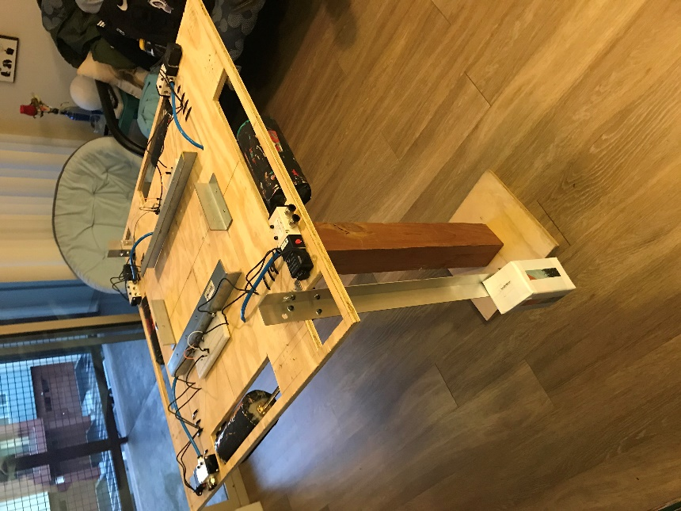

Project Sponsor: General Atomics
Sponsor Mentor: Scott Miller
Instructor: Dr. Sarah Oman

DISCLAIMER
This report was prepared by students as part of a university course requirement. While considerable effort has been put into the project, it is not the work of licensed engineers and has not undergone the extensive verification that is common in the profession. The information, data, conclusions, and content of this report should not be relied on or utilized without thorough, independent testing and verification. University faculty members may have been associated with this project as advisors, sponsors, or course instructors, but as such they are not responsible for the accuracy of results or conclusions.

EXECUTIVE SUMMARY
The NAU ME486 CubeSat capstone team was contracted by General Atomics (GA) Aerospace division to design a testing fixture for CubeSat space satellites. Simulating low orbit environment on ground requires low friction which is provided by an air bearing test stand. The mounting fixture is expected to secure a satellite to a platform that is compatible with air bearing test stand hardware. GA outlined critical criteria for the design to be: limit the tilt of the platform to 30deg from rotational axis, secure CubeSat to the test stand, and must reposition the CG to the rotational axis and in the plane of the platform. Among the customer requirements is device should be entirely non-magnetic, limit weight to the capacity of the air bearing test stand, limit overall size of the device for practical testing procedures, and to have all components avoid obscuring the keep-out zones on the CubeSat.
The platform for the fixture is a square plywood board with side length 762mm by 12.7mm thick. This platform supports all the components for the mounting fixture. On each edge, a 310mm x 70mm rectangular cutout allows free travel for horizontal counterweights. On two corners of the platform are 80mm square cutouts which are utilized for the vertical counterweights. On the bottom side of the board at each rectangular cutout, a power screw assembly with a 3lb weight is secured to the board. One end of the screw assembly is fitted with a bearing allowing rotational while the other end is fitted with an adapter to accept a motor shaft. On the adapter end, a 3/8” pneumatic air wrench is fitted into the adapter. The air wrench create rotation in the power screw, and this displaces the 3lb weight. To control the travel distances, 2-way solenoids are attached to the top of the platform which is connected to the air wrenches and is controlled by an Arduino program. The vertical counterweights are supported by aluminum angle rod at 533.4mm length below the platform. The rods are secured to the platform with corner braces. Pre-calculated notches were drilled into the rod to secure the vertical weights and thus lowering the assembly’s center of gravity, according to the payload. To secure the CubeSat to the platform, two aluminum angle rods at 366mm in length accept the tabs from the CubeSat prevent movement vertically and sideways. Two additional, short angle rods secure the front and back, so the CubeSat does not slide forward/backward. The description above is composed of non-magnetic components and has a total weight of 39.7 lbs. The total cost of the build was $964 ± $75, when considering the model test stand and model CubeSat.
During the validation phase, the CubeSat team tested the as-built CG of the fixture alone. The methodology was setting all the counterweights to their center positions. A 1.5cm diameter pin was fixed to the center of the fixture on the bottom side. The fixture was placed on a flat surface and set to a level plane using a bubble level. All supports were removed from the fixture and the platform did not tilt over but balanced itself on the pin. To validate the fixtures ability to refocus the CG, a 3lb test weight was placed at an arbitrary location within the acceptable limits of the device. The CG of the test weight was input into the Arduino program where a series of MATLAB calculations were performed to determine the total distance to displace the counterweights. Another result from the Arduino/MATLAB program was duration to activate the pneumatic motors which is related to the travel distance. Once the fixture completed the refocusing, the platform was placed on a flat surface once again. In this trail, the platform tilted 3deg to one corner. To validate displacing the CG in the vertical direction, the horizontal weights were placed at their max positions to avoid any effects from those weights. The 3lb test weight was placed within the model CubeSat at a known distance from the plane of the platform. This distance was used to manually position vertical counterweights to oppose the moment from the CubeSat/test weight. The mounting fixture was put onto one of the edges and aligned to the vertical normal using a bubble level. Once oriented to the normal, the supports were removed once again. In these trials, the platform would remain upright for 3-8 seconds. Considering all noise effects from the test, the CubeSat was effective in relocating the CG to the rotational axis and being within the plane of the platform.

ACKNOWLEDGEMENTS
We are incredibly grateful to all who have helped our team with designing and creating a successful CubeSat testing fixture. We would like to acknowledge and give thanks to all of our professors who taught us the knowledge that aided in creating our project. We specifically would like to thank Dr. David Trevas and Dr. Sarah Oman for leading us throughout capstone classes and providing good advice and check ins to verify that we are on schedule. We thank Perry Wood, Robin Tuchscherer, and Dr. Jennifer Wade, for aiding in further learning throughout the design process, and aiding in answering key questions that came about during the project. We also sincerely thank the clients from General Atomics, Scott Miller, Robert Batz, Robert Oakley, John Turner, and Geno Pinczewski, for taking the time to aid us throughout the design process and for working with us throughout the year.

TABLE OF CONTENTS
Contents
DISCLAIMER 1
EXECUTIVE SUMMARY 2
ACKNOWLEDGEMENTS 3
TABLE OF CONTENTS 4
1 BACKGROUND 2
1.1 Introduction 2
1.2 Project Description 2
2 REQUIREMENTS 2
2.1 Customer Requirements (CRs) 2
2.2 Engineering Requirements (ERs) 3
2.2.1 ER#1: Accept CubeSat (Lifts Weight), Target = 24 ± 2 kg 3
2.2.2 ER#2: Movability of CG in all Axis, Target = 50 ± 2 mm 4
2.2.3 ER#3: Limit Tilt Degree, Target = 35 ± 1.75 degrees 4
2.2.4 ER#4: Allow for 320 Degree Rotation, Target = 360 degrees 4
2.2.5 ER#5: Limit Total Weight, Target = 50 ± 2 kg 4
2.2.6 ER#6: Limit Size, Target = 3.5 ± .045 $m3$ 4
2.2.7 ER#7: Material Strength, Target = 200 - 10 MPa 4
2.2.8 ER#8: Lifetime Cycle, Target = 10,000 ± 100 cycles 5
2.2.9 ER#9: Budget, Target = $2,600 ± $300 5
2.3 Functional Decomposition 5
2.3.1 Black Box Model 5
2.3.2 Functional Model 6
2.4 House of Quality (HoQ) 7
3 DESIGN SPACE RESEARCH 8
3.1 Literature Review 8
3.2 Benchmarking 8
3.2.1 Subsystem Level Benchmarking 9
3.2.1.1 Subsystem #1: Counterweights to Displace CG 9
3.2.1.1.1 Existing Design #1: Power Screw to Support Counterweights 9
3.2.1.1.2 Existing Design #2: Rails to Support Counterweights 9
3.2.1.1.3 Existing Design #3: Pistons to Support Counterweights 9
3.2.1.2 Subsystem #2: Securing CubeSat to Platform 9
3.2.1.2.1 Existing Design #1: Clamps from CSD 9
3.2.1.2.2 Existing Design #2: Ratcheting Straps 9
3.2.1.2.3 Existing Design #3: Rails 9
3.2.1.3 Subsystem #3: System for Displacing Counterweights 10
3.2.1.3.1 Existing Design #1: Stepper Motor 10
3.2.1.3.2 Existing Design #2: Pneumatic Motor 10
3.2.1.3.3 Existing Design #3: Manual 10
4 CONCEPT GENERATION 10
4.1 Morphological Matrix 10
4.2 Design Variants 10
4.2.1 Design Variant 1 11
4.2.2 Design Variant 2 11
4.2.3 Design Variant 3 11
4.2.4 Design Variant 4 12
4.2.5 Design Variant 5 12
5 DESIGN SELECTED – First Semester 13
5.1 Pneumatic Subassembly 14
5.2 Counterweight Subassembly 15
5.3 Securing Subassembly 16
5.4 Electrical Subassembly 17
5.4.1 Hardware 18
5.4.2 Programming 19
6 IMPLEMENTATION – Second Semester 20
6.1 Design Changes in Second Semester 20
6.1.1 Design Iteration 1: Change in Securing Subsystem Discussion 21
6.1.2 Design Iteration 2: Change in Z-Direction Counterweight System Discussion 21
6.1.3 Design Iteration 3: Change in Pneumatic System Discussion 22
6.1.4 Design Iteration 4: Change in Electrical System Discussion 23
7 RISK ANALYSIS AND MITIGATION 24
7.1 Potential Failures Identified First Semester 24
7.2 Potential Failures Identified This Semester 25
7.3 Risk Mitigation 25
8 ER Proofs 25
8.1 ER Proof #1 – Accept CubeSat (Lift Weight) 25
8.2 ER Proof #2 –Movability of CG in all Axis 26
8.3 ER Proof #3 – Limit Tilt Degree 27
8.4 ER Proof #4 – Allow for 360 Degree Rotation 27
8.5 ER Proof #5 – Limit Total Weight 28
8.6 ER Proof #6 – Limit Size 28
8.7 ER Proof #7 – Lifetime Cycle 28
9 LOOKING FORWARD 28
9.1 Future Testing Procedures 28
9.1.1 Testing Procedure: Final Test on Entire Assembly 28
9.1.1.1 Testing Procedure: Objective 28
9.1.1.2 Testing Procedure: Resources Required 29
9.1.1.3 Testing Procedure: Schedule 29
9.2 Future Work 29
10 CONCLUSIONS 29
10.1 Reflection 30
10.2 Post Mortem Analysis of Capstone 30
10.2.1 Contributors to Project Success 30
10.2.2 Areas for improvement 31
11 REFERENCES 33
12 APPENDICES 34
12.1 Appendix A: CubeSat Testing Fixture House of Quality 34
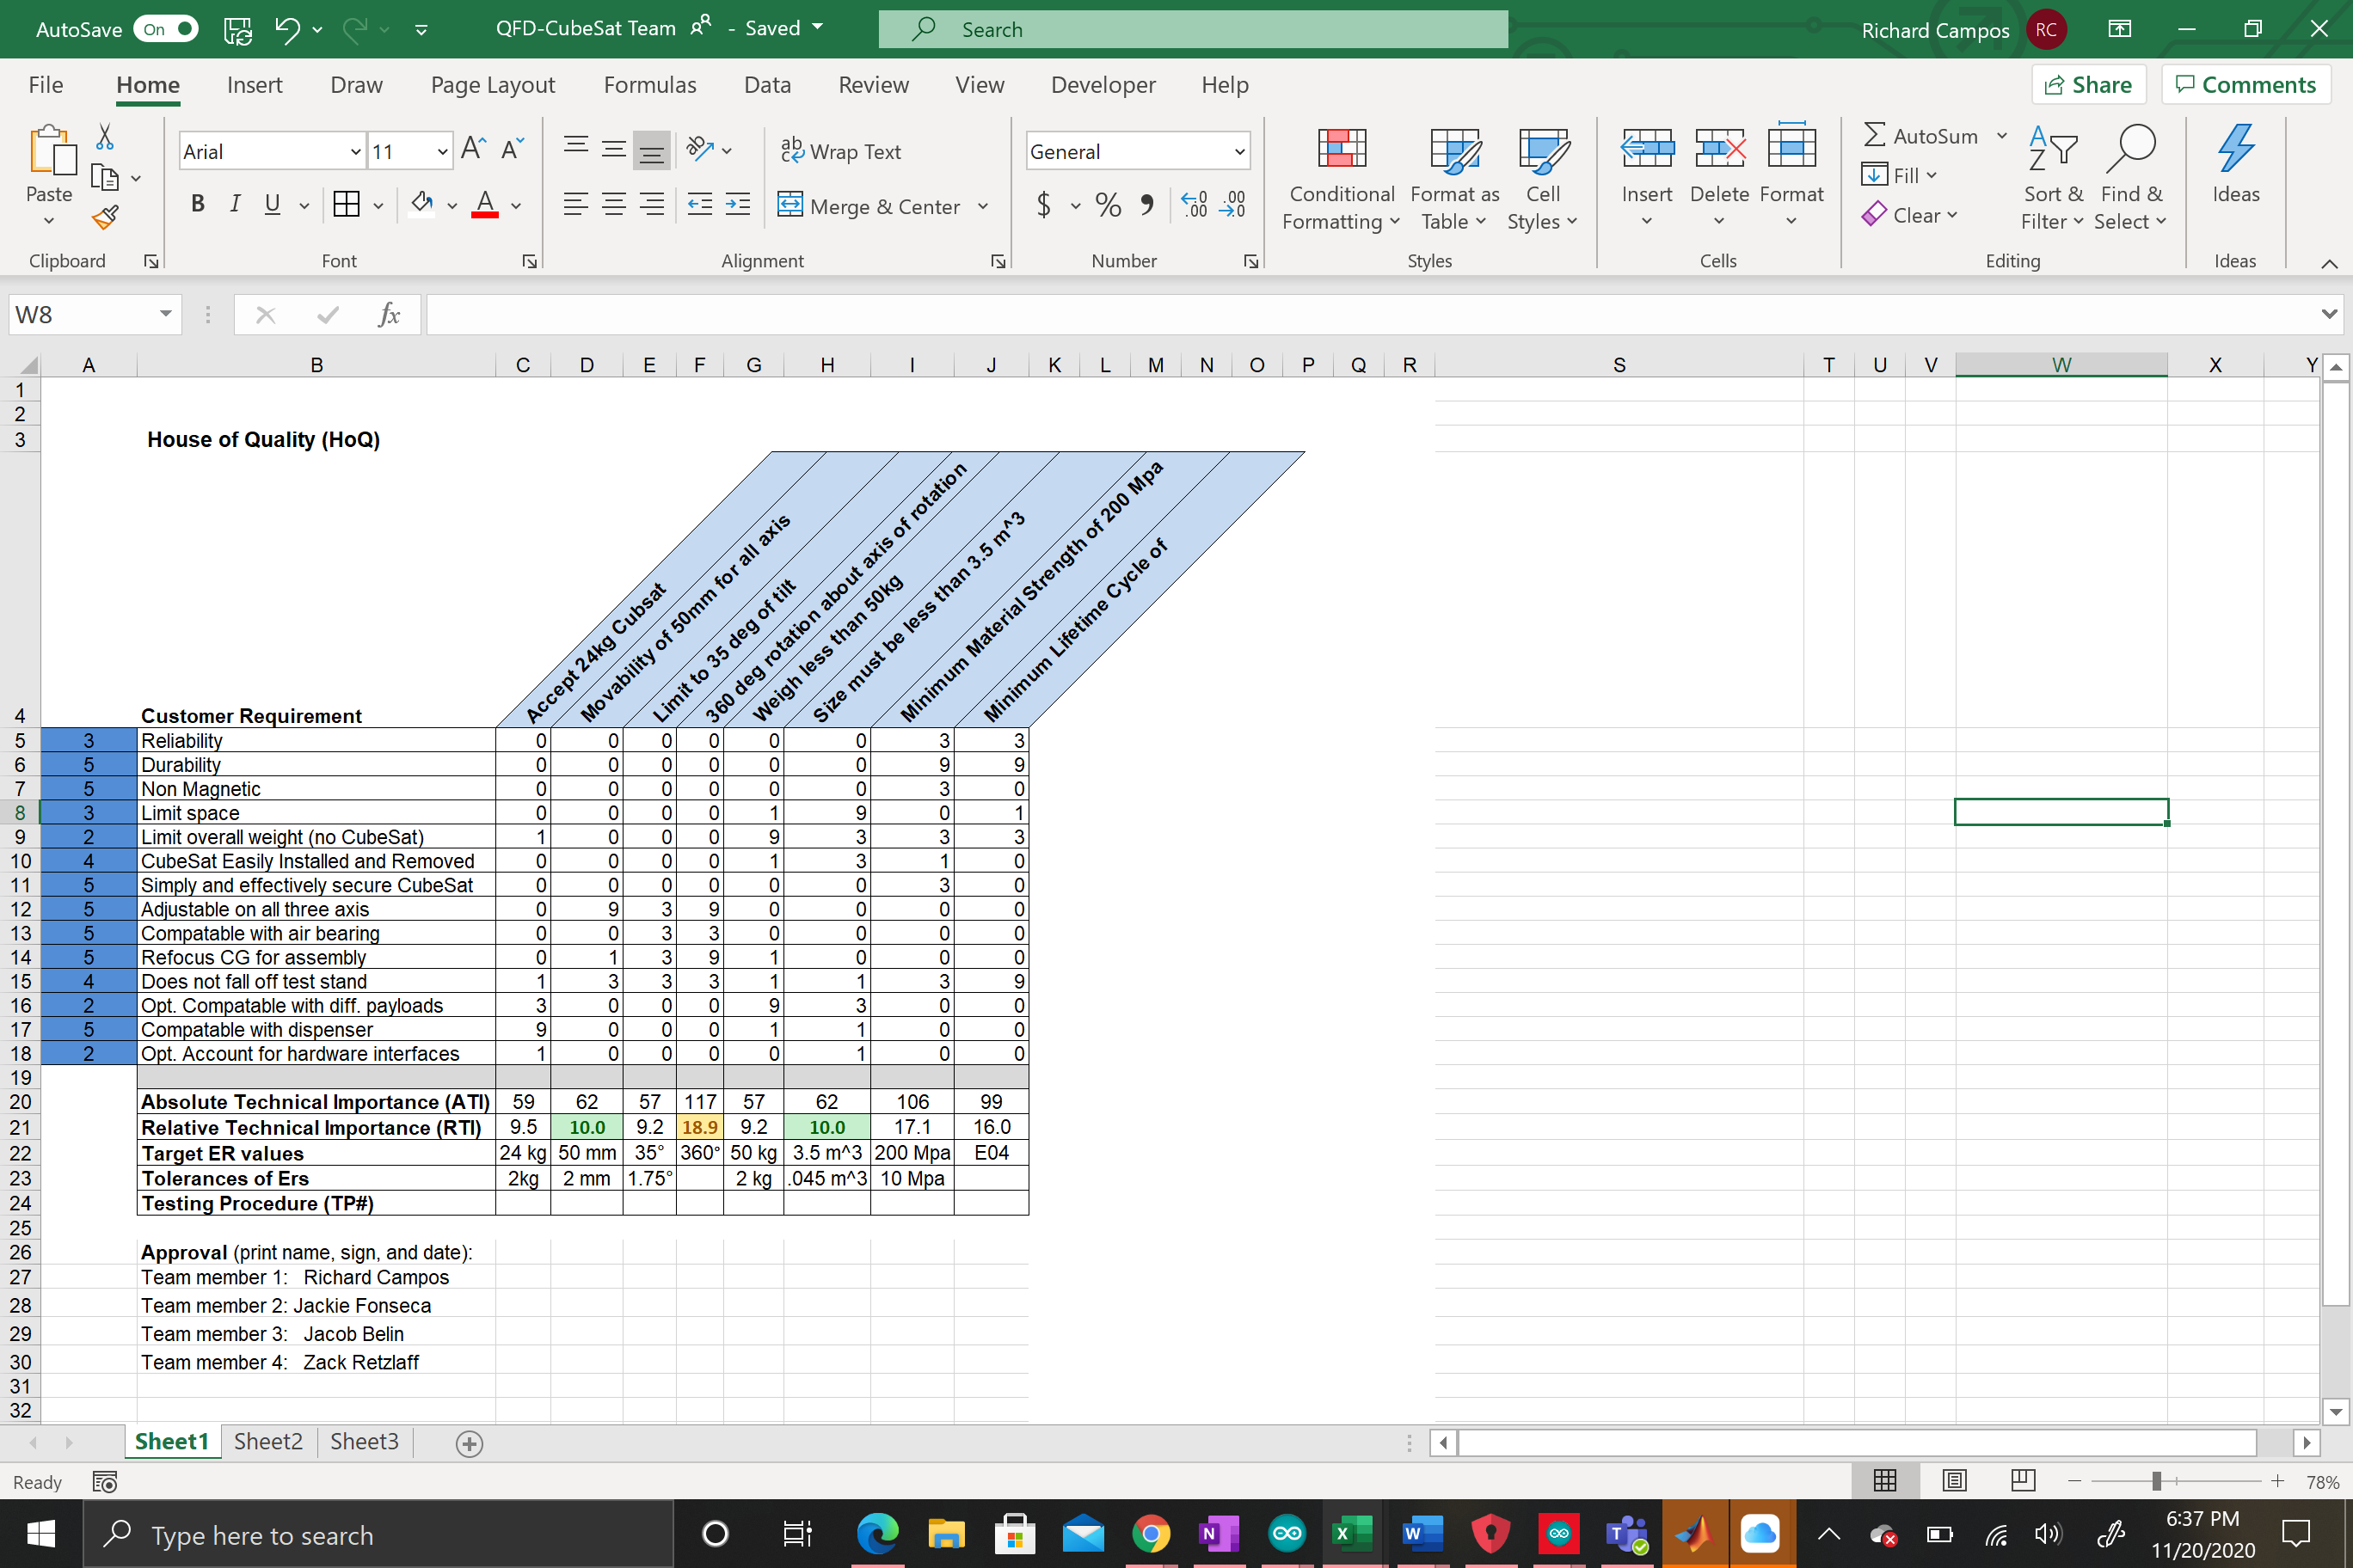 34
12.2 Appendix B: Failure Modes and Effects Analysis 35

BACKGROUND

Introduction
This project originated by the company General Atomics creating the project in which a team of students would come together to design a testing fixture that would secure a 12U CubeSat to an air bearing stand while relocating the center of gravity (CG) of the entire assembly. The fixture must be a adaptable to take in different payloads of where the weight of the CubeSat is located and correct the CG to a specific point directly above the air bearing stand. It must also assure that the 12U CubeSat is secure to the testing fixture and will not tilt past a certain degree.
The project was initiated to create new testing plans for the CubeSat. Currently, tests ran on the CubeSat are performed while the satellite is stationary on a flat surface. However, with this new design the tests ran on the satellite would be performed on an air bearing stand, which allows for the tests to represent zero gravity which is what it will undergo in space. The testing fixture primarily allows for more accurate tests to be ran on the satellite before launching it into space.

Project Description
Following is the original project description provided by the sponsor. The main goal of the project was to create a platform to affix to an air bearing stand to align the CG of the CubeSat with the CG of the air bearing. The goal was to design the platform for a 12U CubeSat with a stretch goal to be compatible with 3U and 6U CubeSats. Other goals of the project were to make sure the CubeSat does not exceed an angle of tilt of thirty degrees and stays on the platform for the entire duration of the test. The goal of this project was to create a platform compatible with an air bearing stand to align the CG of a CubeSat with the CG of the air bearing.

REQUIREMENTS
For this project, our client provided the team with their needs and some engineering requirements. Most of the engineering requirements were taken directly from the project description PDF given to the team at the start of the project. The team dissected this list, then met with our clients to determine if there were any other key things to focus on for the duration of the project. After compiling needs from our clients and from the initial project description, the team was able to come up with many customer and engineering requirements to aid in the design process.

Customer Requirements (CRs)
The original project description that was provided by the clients had a list of the immediate customer requirements. With further discussion and more information from the client, the team determined the following as the CRs for the CubeSat testing fixture design. The CRs for this project are: the device needs to be reliable, durable, non-magnetic, it needs to limit space and weight, the CubeSat must be easily installed and removed, the CubeSat must be secure, it has to be adjustable in all three axes, compatible with an air bearing stand and refocus the CG for the entire assembly. The following is the reason behind each CR and how they are being met within the design.
The design’s primary need is to refocus the CG to the location where the air bearing stand meets the fixture. This CR is met throughout the design due to the fact that it is the primary focus. It is accomplished by utilizing counterweights to relocate the CG of the entire assembly.
The teams design, or the testing fixture is expected to be the interface between the CubeSat and the air bearing stand. From this general function, the CubeSat should have an efficient method for installing, securing, and removing the CubeSat from the fixture and prevents the whole fixture from falling off the test stand. If the fixture becomes cumbersome to work with, there is potential to damage the satellites and the mounting fixture. Our design incorporates these requirements by utilizing tabs on the edges of the CubeSat. These tabs are designed by the clients, General Atomics, to anchor the CubeSat inside their dispenser device. The teams design utilizes the shape of the tabs to create a slot for the CubeSat edges to slide into and the tabs prevent the CubeSat from coming away from the platform.
In a discussion with the client, the team noticed that the clients mentioned the repeatability in utilizing the design for their testing purposes. The team interpreted the customers repeatability as a call for the device to be reliable and durable. With the team’s choices in material and product selection, the team was able to satisfy these CRs. The team assured that both the material would be strong enough to withstand multiple iterations of testing, and that the equipment that was chosen was highly sensitive and accurate.
The next CRs were created based on how the clients are intending to utilize the design. One test that the clients perform on the CubeSat and utilize the design for is inside of a Helmholtz coil to null the magnetic field to mimic the magnetic field in space. This meant that the design must be built entirely of non-magnetic components as this will interfere with the measuring devices inside the CubeSat. In addition, the device must be transported between different locations within the client facilities and around small chambers such as the Helmholtz coil. Therefore, the device was designed to have a limit geometric size, and a limit of total weight.
The customer requirements discussed above were maintained throughout this semester and the former. We noticed those are the requirements that influence our design decisions the most and we notice their implementation into the design more explicitly than others. One requirement that changed since the previous semester is the compatibility with other payloads beyond CubeSats. General Atomics is an advanced technology company and have many applications they could test. We attempted to create securing mechanisms that could adjust for different geometries but incorporating this requirement made calculating the CG extremely complex. We are now designing the mounting fixture to accept only CubeSats, regardless of its size. Unfortunately, this does not allow our fixture to be compatible with the CSD device that the client uses for orbit missions. This is the only modification to that requirement. Lastly, our fixture was requested to compensate the CG effects of a cord hanging from the CubeSat during a simulation. This requirement was difficult to satisfy with a pneumatic, non-magnetic system so we asked our client to remove that from our CR list. In the future, General Atomics is expecting to use remote connections to communicate simulation data instead of a hardline.
The CRs were evaluated by the team and assigned a rank which correlates to its importance in the design. The max rank of 5 was given to the following CRs: non-magnetic, secure CubeSat, compatible with test stand, and refocus the CG. These CRs are embodied most by our design. The CRs that followed with a rank of 4 was, the fixture must not fall of the test stand and installing the CubeSat must be practical. Limiting the volume of the fixture and being reliable were assigned rank 3. We are confident our material selection is sufficient to produce a reliable device that isn’t too bulky, so we reduced the rank of these requirements. The lowest ranked CR was limiting the weight of the mounting fixture. The client gave a generous tolerance for the weight of our mounting fixture, so this was not critical in the overall design but is more critical for refocusing the CG. Since refocusing the CG is among the highest ranked, we give weight considerations the least priority.

Engineering Requirements (ERs)
Every design project must have measurable engineering requirements (ERs) that the final product must accomplish. Each of the ERs must have a specific target and tolerance value associated with it and must be able to be tested for. Each of the ERs that are associated with this design project are listed below with the associated target and tolerances.

ER#1: Accept CubeSat (Lifts Weight), Target = 24 ± 2 kg
This ER is vital to the design because the fixture would not be able to complete its necessary task without fulfilling this ER. The target value for this is based on the weight of the CubeSat itself. The fixture must be able to hold up the weight of the CubeSat in order to perform the necessary tests and to align the CG.
The target and tolerance on this ER were provided by the client, General Atomics, based on the known tolerances of the weight of the CubeSat. This ER is important because it gave the team a baseline of what materials were able to be chosen. In order to support the maximum weight, the material choice had to be strong enough to hold the weight without causing deformation.

ER#2: Movability of CG in all Axis, Target = 50 ± 2 mm
This ER was provided to the team through the clients wants and needs for this device. The client is expected that the device is able to displace the CG by fifty mm in all directions from its original position. The team accomplishes this by utilizing counterweights and providing that the counterweight rails are long enough, or the weights are heavy enough to satisfy this requirement.
The tolerance of two mm was given to this ER based on a sense of accuracy of the device. With the tolerance of two mm, the team is able to assuredly tell the clients that the device is accurate at relocating the CG.

ER#3: Limit Tilt Degree, Target = 35 ± 1.75 degrees
This ER was created to assure that the device does not fall off the air bearing stand during testing. The target value was given directly from the client to ensure that the tilt does not exceed 35 degrees from the z-axis. It is set to allow for more security of the CubeSat during the testing process.
The tolerance was also provided from the clients to assure there is accuracy within this ER.

ER#4: Allow for 320 Degree Rotation, Target = 360 degrees
This ER was created to allow for the CubeSat fixture to rotate freely, like how it does in space. However, since the fixture is attached to an air bearing stand that does allow for this free rotation around the z-axis, this ER is more associated with the testing procedures that General Atomics will be utilizing our device for. Therefore, a tolerance of zero was thought to be the most accurate.

ER#5: Limit Total Weight, Target = 50 ± 2 kg
The air bearing stand that the fixture assembly will be attached to during testing has a maximum weight limit associated to it. Because of the known weight limit of the air bearing stand and its tolerance, the following values were considered to be the max weight possible for the design, 50 kg. This was decided based on the maximum allowable weight that the air bearing stand can with stand minus the known weight of the CubeSat.

ER#6: Limit Size, Target = 3.5 ± .045 $m^{3}$
The client will be utilizing the fixture inside of a Helmholtz coil, for testing purposes on the CubeSat. Due to this, the overall size of the design must be able to fit within the Helmholtz coil. Therefore, the ER of limit size had an original target of 9 cubic meters. But, after further discussion and consideration, the team reduced the target to 3.5 cubic meters, to allow for more practical transportation and handling. The tolerance was decided on just to assure that the entire size of the design was within a reasonable estimate of the target.

ER#7: Material Strength, Target = 200 - 10 MPa
This ER was created to coincide with the requirement to withhold the weight of the CubeSat, ER#1. It was also created to assure that the material would be able to withhold the counterweights, and any damage that may occur to the device. To withstand all of these the target was set at 200 MPa.
The team created a tolerance of 10 MPa, to allow for wider range of material selection possibilities. The material strength can exceed 200 MPa but must not be below 190 MPa, in order to assure that little deformation will occur when the CubeSat and counterweights are on the fixture.

ER#8: Lifetime Cycle, Target = 10,000 ± 100 cycles
This ER was made to ensure that the final design could be used for a reasonable amount of time in the future. The target was set at 10,000 cycles, because that is how many uses the team wants from the device to allow for it to be used multiple times.
The tolerance was determined by some of the knowledge learned in prior classes that the team has taken during their engineering education career.

ER#9: Budget, Target = $2,600 ± $300
In the first semester, the team created a tentative Bill of Materials and associated costs of the items. The total cost for this list was less than $600. Over the course of the summer, the team concluded our design would need more robust and precise components. The additional parts needed to mesh the new high performing materials resulted in a longer list of items to purchase. Our initial budget for the prototype was $1000 where $600 used for materials and $400 reserved for manufacturing and machining costs.
The maximum cost for this project is expected to be much more than $1000 because our design needs to incorporate high-precision, high-accuracy components. These high-performance materials cost extra but increases accuracy of our design, maintaining the client requirements. Apart from better materials, our design includes 6 rail assemblies, so the quantities purchased are always as a set of 6 or more. The final comment about our increased cost considers the pneumatic system. To operate an air system, the design needs more attachments to regulate and direct air. Electronics are an absolute benefit to any design because they are lightweight, low costing, and efficient. Our design sacrifices electrical components because of our non-magnetic requirement.

Functional Decomposition
A functional decomposition was performed for the project in order to understand the project more and know how exactly the design will work. The team created a black box model and a functional model to break down different types of flows, material, energy, and signal. These flows are what are interacting and entering and exiting the design for the entire project.

Black Box Model
The black box model breaks down each of the flows that are entering and exiting the overall design. These flows are material, energy, and signal flows. The black box model for the CubeSat testing fixture can be seen below.
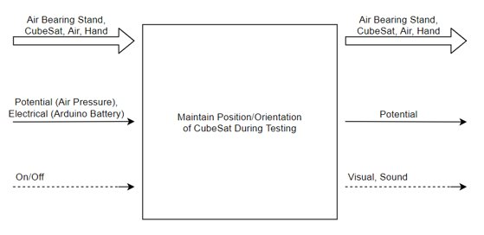
Figure 1.Black box model for the CubeSat testing fixture device
Where the key for the black box model is shown below. This same key also relates to the functional model.
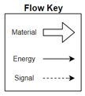
Figure 2. Flow key for the black box model and functional model

The material flow for the black box model remains the same which are the air bearing stand, CubeSat and a hand. This flow remains the same because the device just comes in to contact with these materials and does not alter them in any way. The CubeSat is attached to the fixture, and the fixture is attached to the air bearing stand, and so after use these both will get disconnected. The hand is just inserted and exited because it is what actuates the device and attaches all of the parts.
The energy flow into the device is potential energy and electrical energy. The potential energy is in air pressure, this is what powers the counterweight sub-assembly and powers the most important part of the device. The electrical energy is through batteries, which powers the Arduino, and essential powers the electronic components that actuates the device. The energy that is leaving the device is potential energy. This is both through gravitational energy and more air pressure. As the air is being put into the device, it must also escape some. The device also changes the CG and therefore creates a gravitational potential once the CubeSat is removed.
The signal flows entering into the device is a on/off signal and leaving are visual and sound signals. In order to get the device to work the Arduino must be turned on, and the program must be run through. Then as the device is working, the counterweights can be seen moving, and the motors and air pressure running through the system can be heard.
All of the signal flows are what is interacting with the device. However, the black box model does not describe fully what happens to these flows through the device.

Functional Model
The functional model was created to further develop and understand the different flows associated with the device. Each of the flows that were on the black box model is within the functional model, but just further expanded to show how they interact within the device. The functional model that was created for the project can be seen below.
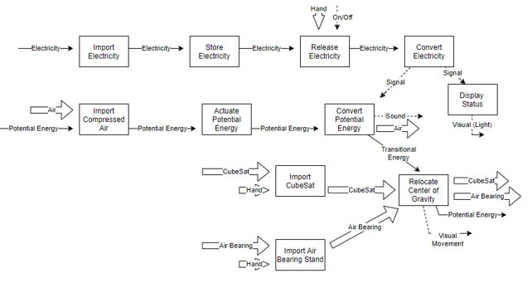
Figure 3. Functional model for the CubeSat testing fixture device
When following each of the flows it describes how they interact, and what they accomplish on the project. Neither the black box model or functional model had to be changed, because it still represents what is occurring within the device for the final product.

House of Quality (HoQ)
The House of Quality (HoQ, Appendix A) has been essential to the team during the design process. For our project, it helped us determine which engineering requirements we needed to pay more attention to, and which requirements were secondary. This gave us general requirements to design for and sparked the design process.
As seen in the lower portion of the HoQ, the highest ranked engineering requirement was allowing the CubeSat and its fixture to be able to rotate 360 degrees about a central axis. It makes sense as to why this had that highest Relative Technical Importance (RTI) because the clients had made it clear that the device, when operating tests, should be free of any tethers or wiring that would prevent full rotations.
While the next highest ranked requirements were the material strength and minimum lifetime cycle of our fixture, when this was presented to the client, the team was informed that these requirements should be of no real cause of concern when designed the device.
With that in mind, the next highest requirements, which also happened to be equally ranked was the movability of 50 mm on all three axes and limiting the size to 3.5 m³. The movability on three axes was important to the team because this was the most basic mechanical function that the device could perform in order to fulfill any of the clients’ needs. The limiting of the size of the fixture was important because the tram was tasked to reduce the overall weight of the fixture, and so one of the easiest ways to do this would be to minimize the overall size of the fixture.
The lowest ranked requirements were the ability of the fixture to accept a 24 kg CubeSat and limiting the tilt to 35 degrees. These were ranked relatively low because the team determined, while constructing the HoQ, that these would be relatively easier requirements to meet for any final design that was chosen.

DESIGN SPACE RESEARCH
Prior to engaging in the project, the team was unfamiliar with CubeSats and the associated testing procedures. After initial research, the team gained high level understanding of a CubeSat satellite. Before the 2020 pandemic response, the team was fortunate to meet with the client in-person to gain an in-depth understanding of General Atomics’ products. In this meeting, we gathered the client expectations but most importantly, their in-house documents detailing the specifications of their satellites, testing devices, and testing procedures. A summary of that information is given in 3.1 Literature Review section. One obstacle in this project was much of the research and testing devices used in this industry are safeguarded through confidential disclaimers. Nonetheless, sources like YouTube.com and Wikipedia offered great insights into form and function of air bearing test stands and generic CubeSat testing fixtures.

Literature Review
The documents procured by the client are composed by a third party: Planetary Systems Corporation (PSC). One document in the docket provided a detailed overview of the Canisterized Satellite Dispenser (CSD) device. This document provided the team with information of how the CSD secures the CubeSat during travel to low orbit. The document explains the CubeSat is manufactured with pre-formed tabs located near the bottom face of the CubeSat and do not protrude from the solid volume. The CSD document provides many illustrations to explain the benefits and drawbacks of using different mechanisms to secure the CubeSat within the CSD. One of major factors to consider for securing the CubeSat is vibration and resonance. Creating a fixed rail for the tabs to slide into would not be a valid option for securing the CubeSat because to append to such a rail, there needs to be a clearance enough for the tabs to slide the entire length of the rail, resulting in vibration of the CubeSat. [1]
Another document in the PSC docket provides specifications and dimensions for a 3U, 6U and 12U CubeSat satellites. In the early stages of the design process, the team anticipated to design the fixture to be compatible with all sizes of a CubeSat and perhaps extend other projectile devices. The dimensions provided gave the team insight into the overall size of the fixture. This was key detail to analyze to meet the ER for limiting the size of the CubeSat and Fixture assembly. The 3U, 6U and 12U CubeSat each had a length of 366mm, and the max width was given as 239mm. The other latent bit of information in this document was the “keep-out” zones, as coined by the client. These zones are open faces on the CubeSat that allows technicians to interface with the CubeSat and make any modifications. One of the team’s CRs was to avoid obscuring these zones. [1]
One highlighted CR is the designed fixture should be non-magnetic. The client informed the team current CubeSat systems are tested within a Helm Holtz Coil testing chamber. This chamber would normalize external magnetic effects and produce a uniform field. The purpose of this is to simulate Earth’s magnetic field without abnormalities. The chamber is not a very large enclosure so the document was instrumental in providing the team with the ER criteria for the overall size. [2] The team extended research in this area to determining which types of tests are conducted in these chambers and if there are any design obstacles that would result from these standard tests.

Benchmarking
As mentioned in the section header, the space technologies industry is safeguarded by confidential disclaimers. Considering this obstacle, the team utilized overview and demonstration videos to determine what subsystems are generally included on CubeSat testing fixtures. The team used these lessons to benchmark the device at the sub-system level.

Subsystem Level Benchmarking
From the demonstration videos procured and considering the ERs driving the design of our device, the team outlined three subsystems critical to producing an effective device. The team attempted to benchmark these subsystems while considering the remaining ERs and CRs. Combined with the limited public information, the team included existing designs not unique to CubeSats or space technologies.

Subsystem #1: Counterweights to Displace CG
The counterweight subsystem is expected to receive input potential energy and use that energy to relocate the CG. The potential energy was expected to be either electrical or pneumatic.

Existing Design #1: Power Screw to Support Counterweights
This existing design was observed in a demonstration video. The weights were positioned beneath the platform on a power screw assembly. The weighs were rotated on the screw and this displaced the counterweight, as necessary.

Existing Design #2: Rails to Support Counterweights
A less complex approach than the power screw design, a rail can be used to support the counterweights. This rail would require additional hardware to displace the weights, if not being moved manually. Another detail of this rail option is the size must be compatible with the size of the counterweights.

Existing Design #3: Pistons to Support Counterweights
This design uses compressed fluid (air/liquid) to move a piston in one direction. The team would secure counterweights to the free end of the piston. The piston would travel a prescribed distance. The drawback with this method is maintenance of the piston resulting from the compressed fluid. Additionally, the piston is limited to one direction of travel.

Subsystem #2: Securing CubeSat to Platform
In the initial client meetings and CR, the device was expected to have a practical method for securing the CubeSat the platform. In testing scenarios, it is not feasible to have a cumbersome method of securing the CubeSat and should not disrupt the normal operation of the CubeSat or the testing procedures.

Existing Design #1: Clamps from CSD
For travel into low orbit, the PSC uses a series of screw clamps uniformly distributed along the length of the tabs on each side of the CubeSats. The method used in the CSD is not a viable option only when considering the screw clamps had to be tightened individually.

Existing Design #2: Ratcheting Straps
This design is used across many applications and would be a very basic approach to this subsystem. Straps are available in various fibers, aluminum, and hard plastics so this is both cost effective, minimizes overall weight to the device, and can be non-magnetic. A drawback of this option is the risk of obscuring the keep-out zones mentioned in above sections.

Existing Design #3: Rails
The CubeSat is manufactured with tabs at near the bottom edge. These tabs run the entire length of the CubeSat. The geometry of these tabs is available to the team via PSC documents. This design would be efficient method to being a practical method to securing the CubeSat but also mentioned in the Literature Review section, the device risks adverse effects from vibrations.

Subsystem #3: System for Displacing Counterweights
Subsystem #1 would be rendered ineffective without an accompanying device to convert input potential energy into mechanical energy to displace the counterweights.

Existing Design #1: Stepper Motor
The fixture is required to be entirely non-magnetic, but one route of design is to create a separate device that includes a drive to be inserted into hub to create rotation

Existing Design #2: Pneumatic Motor
The most effective method to displace the counterweights is to use an electric motor but violate the requirement of being non-magnetic and creating a separate device to accompany the fixture was not a design goal for the team. To mitigate this issue, pneumatic motors are available in non-magnetic assemblies and are shown to create sufficient energy to displace the weights, as necessary.

Existing Design #3: Manual
The simplest method is to displace the counterweights manually. This technique would relinquish the use of many accompanying components to drive a motor. The downside of this method is reduction in precision of refocusing the CG of the fixture assembly. One of the client expectations was to create a device entirely self-contained and thus, automatic.

CONCEPT GENERATION
This section highlights how the team determined the final design. The team started by outlining the CRs and ERs, then did research to determine potential designs to meet those needs. The concept generation process was extensive for this project as there were many different ideas. A morphological matrix was created to aid in the sketch process. The team also followed the functional diagram and black box model shown above.

Morphological Matrix
A morphological matrix is a chart that lists multiple sub-functions with a design concept for each. This is important in the concept generation process since the team can come up with concepts for each sub-function and thereafter come up with a full design variant. The morphological matrix is shown below.
Table 1. Morphological Matrix
Sub-Function | 1 | 2 | 3
Secure 12U | Clamps | Screws | Ratchet Straps/Elastics
Locate CG | Force Sensors | Arduino | Gyroscope
Refocus CG | Sliding Plate | Counterweights | Pneumatic Counterweight
Attach to Air Bearing | Nuts/Bolts | Removable cinch | Pin and key-way
Adjustable Payloads | Compressible Plate | Spring Loaded Plate | Molded fitting
Account for Umbilical | Shorter Side Panels | Short Fixture Panel | Bearing facing one way

Design Variants
The team came up with five design variants using the morphological matrix. Each team member had one final design variant to share with the team and one is a combination of other design variants. All of the design variants are shown in figures below with descriptions.

Design Variant 1
This design variant incorporates a sliding rail system with clamps. The counterweights are attached to the sliding rails which refocus the CG as they are moved in the x-direction and y-direction. This was an interesting concept, the team ultimately decided it would not refocus the CG effectively based on different payloads inserted into the CubeSat. The clamps incorporated into this design were ultimately used for the final prototype.
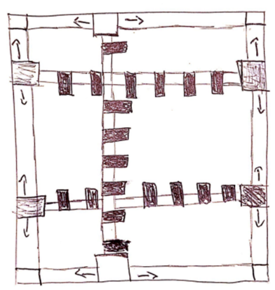
Figure 4. Sliding Rail System

Design Variant 2
This design variant incorporated a power screw and counterweight design. This is what the team is using for the final prototype to move the counterweights in the x-direction and y-direction. However, this design variant did not have an effective method to secure the CubeSat. This concept uses motors to turn the power screws which ultimately moves the counterweights.
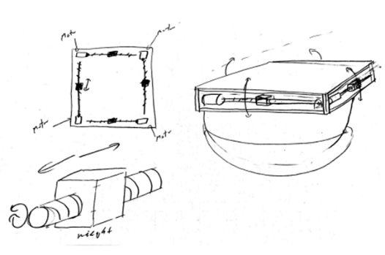
Figure 5. Power Screw - Counterweight

Design Variant 3
This design variant used a pneumatic system to refocus the CG. This variant gave the team the idea to use a pneumatic system because of the non-magnetic requirement. This variant did not have an effective way to secure the CubeSat to the prototype.
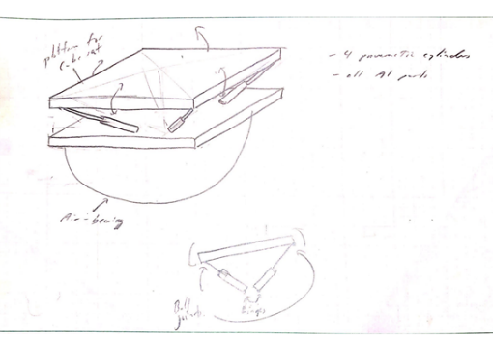
Figure 6. Pneumatic Gimble

Design Variant 4
This design used an octagonal platform with counterweights inserted into the platform in order to refocus the CG by retracting or extending them. This variant used a pneumatic system which was ultimately included in the final prototype. The clamping mechanism incorporated into this design was the system given to the team by General Atomics. Much of the ideas from this design variant was used in the final prototype.
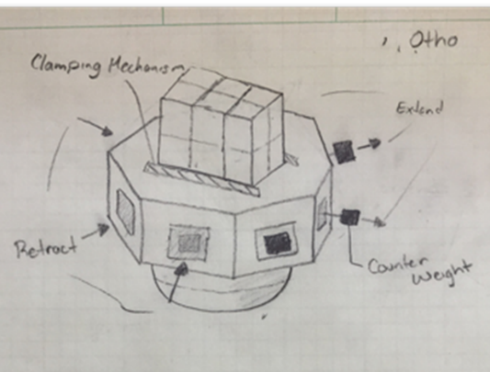
Figure 7. Pneumatic Rod Counterweights

Design Variant 5
This design variant was the design the team moved forward with from concept generation. There were design changes after this sketch, though. This variant includes clamps to secure the CubeSat, has a counterweight system, and uses a sliding fixture to be adjustable to 3U, 6U, and 12U CubeSats. The vertical slides interfered with the keep out zones of the CubeSat so that was something the team had to redesign. This was the most complete design the team decided to move forward with and tweak as needed.
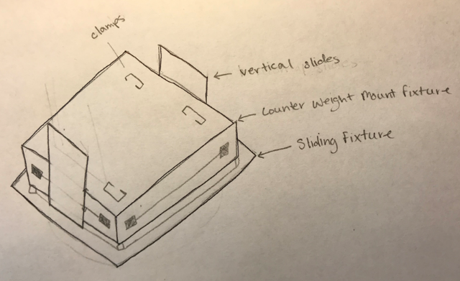
Figure 8. Combination Design

DESIGN SELECTED – First Semester
After much thought and consideration of the design variants, the team decided to combine some of the ideas into one final prototype. The team decided to create a platform geared towards aligning the CG of the platform with the CG of the CubeSat. This is important because it is the primary customer need given to the team by General Atomics. The team broke the design into four different subassemblies. These subassemblies include the pneumatic system, counterweight system, securing system, and the electrical system. The electrical system is broken down into two parts: hardware and programming.
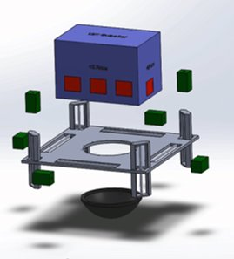
Figure 9. Exploded View Initial Final Prototype
The team altered the initial design from the spring semester to include the fittings and connections for the counterweight assemblies and the adjustment of the counterweights in the z-direction. This correction is shown in the figure below.
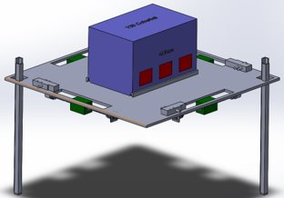
Figure 10. Final Prototype CAD Model
It is clear from the figure that the z-direction counterweights were moved down to account for CG calculations approximated from maximum locations of the CG given to the team by General Atomics. This is explained more thoroughly in the design iterations section below. The team learned a lot during the construction of this prototype. One general takeaway is that you should always have a backup plan during the design process. If some parts do not work out as intended, you might have to redesign with minimal time left to complete the project. The team’s final constructed design is in the figures below. A breakdown of each subassembly are in the sections below.
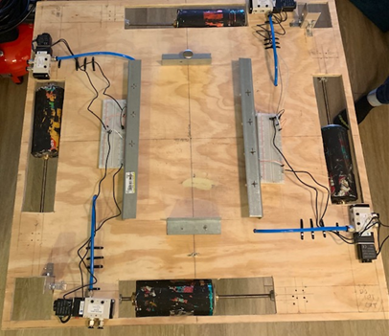
Figure 11. Final Prototype Top View

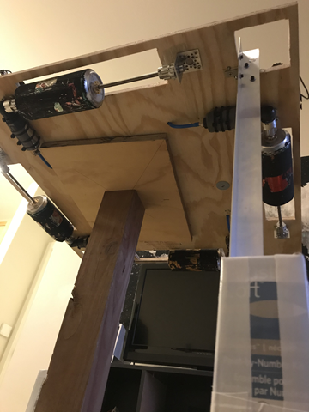
Figure 12. Final Prototype Bottom View

Pneumatic Subassembly
The pneumatic subsystem is used to move the counterweights by using compressed air. The team chose to go the pneumatic route because of the non-magnetic requirement of the testing chamber. Pneumatic motors give off little to no magnetic fields which was critical when determining the motors the team would use. The pneumatic motors are attached to the lead screws with a machined fitting. This fitting was machined utilizing the machine shop on campus under the supervision of Perry Wood. The pneumatic motors came from air wrenches where the team repurposed the socket of the wrench to act as a motor to turn the lead screw.
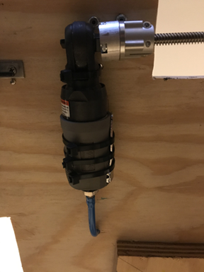
Figure 13. Pneumatic Motor with Hosing
The team used hosing to connect the motor to the solenoids and then the solenoids to the compressor. One design challenge the team faced during this process was tolerances of the fittings. The team had trouble fitting the hosing in the fittings for the solenoid and the pneumatic motor but eventually found the right fittings to work efficiently. After the hosing was connected, the team tested the pneumatic motor first before connecting the solenoids. The solenoids were tested with the electrical subsystem but were eventually tested with the entire system completed to make sure all the pneumatic components worked.
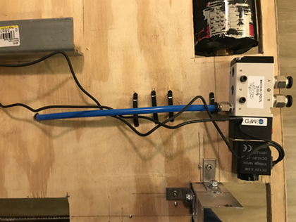
Figure 14. Solenoids with Hosing
The solenoids were attached to the platform using two screws as you can see on the left side of the solenoid in the figure above. A complete figure of all the solenoids and pneumatic motors completed is above where the entire system is mentioned. This system is essential to the prototype because it moves the counterweights the desired distance to realign the CG.

Counterweight Subassembly
This subsystem is utilized to relocate the CG of the entire assembly to a specific location directly centered above the air bearing stand. This assures that the CG is at the correct location so that the tests that are being ran by the clients on the air bearing stand can be accurate. The team decided to use lead screws with pneumatic motors (mentioned above) to align the CG of the platform with the CG gravity of the CubeSat. The team used concrete to create cylindrical molds for the counterweights. The team made the counterweights by molding concrete into cylinders. The molds were based as if the concrete was lead since lead was not readily available to the team to machine. Since this is a prototype, the team decided to use concrete for ease of manufacture and to be able to change the weight more easily since concrete is cheap.
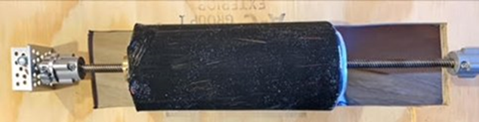
Figure 15. XY Counterweight Assembly
For the z-direction counterweight system, the team had to make a manual railing system by using screws and smaller counterweights. Based on engineering calculations, the team determined the majority of the railing had to be below the platform. By doing this, the team was able to align the center of gravity of the platform accurately.
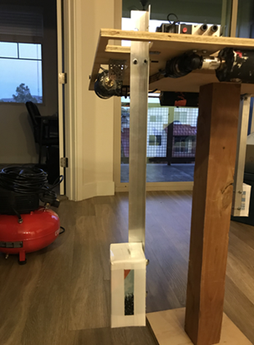
Figure 16. Z Counterweight Assembly
The counterweight subsystems are essential to the operation of the device. Since the XY counterweight systems are automated, it is important to get the calculation of the CG of the CubeSat correct. By doing this, the team wrote a code to displace the counterweights a certain distance based on the initial calculation of the CG.

Securing Subassembly
This subassembly is what affixes the CubeSat to the test platform. In the initial project description, one of the goals was to ensure the CubeSat remains on the platform for the duration of the test. The team planned to go with the clamping system General Atomics provided in the beginning of the semester, but after consultation of lead times and manufacturing costs, the team decided to go with a sliding rail concept. The rail concept works with the tabs of the CubeSat and will ensure the device does not fall off the stand during testing. The figure below shows the securing system directly after affixing the railing to the platform. This figure is before the pneumatic system, counterweight assemblies, and electrical system were added to the prototype.
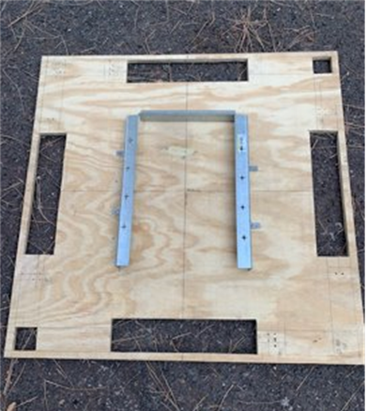
Figure 17. Railing System
The team’s redesign eased manufacturing costs and lead time for this subassembly. Aluminum railing was used since the platform must be non-magnetic. The aluminum railing was cut to the length of the CubeSat and affixed to the platform with L brackets and screws. The front and rear railing components were machined to sit flush with the CubeSat since the front and rear of the CubeSat do not have tabs for the railing to fit. The rear plate is fixed while the front plate slides. This design was incorporated so the CubeSat can be slid into the railing system and then the front plate can be slid to lock the device into place. The finished railing system is shown in the figure below.
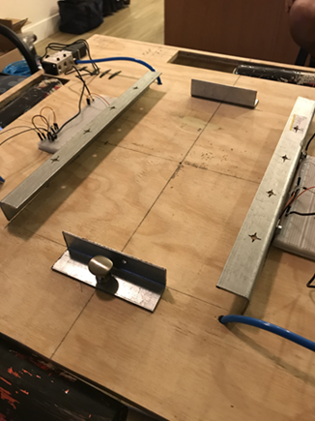
Figure 18. Final Prototype Railing System
The figure shows a knob on the front sliding rail that fixes the CubeSat into place. The securing system is an important component of the design since it meets one of the more important customer needs. This system was tested with the replica CubeSat built by the team and works effectively.

Electrical Subassembly
The electrical subassembly utilized Arduino hardware and programming to actuate the pneumatic motors with solenoids. MATLAB was also used to calculate the distance the counterweights needed to travel to align the CG. In this report, the electrical subsystem is divided into two parts: hardware and programming. These parts are described thoroughly in the sections below.

Hardware
The team used several electrical components to construct the final prototype. Solenoids were used to actuate airflow from the compressor to the pneumatic motors using an Arduino Mega motherboard. The team also used force sensors to calculate the center of gravity of the CubeSat during testing. The sensors were evenly distributed on the team’s testing platform as seen in the figure below.
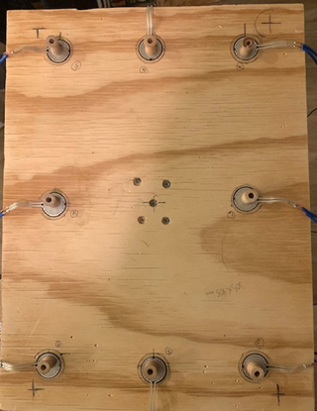
Figure 19. Force Sensor Placement
These force sensors were also connected to the Arduino motherboard the team is using to run the MATLAB code. This circuitry is shown in the figures below. A schematic of the circuit is shown first, followed by all the sensors hooked up to the circuit board.
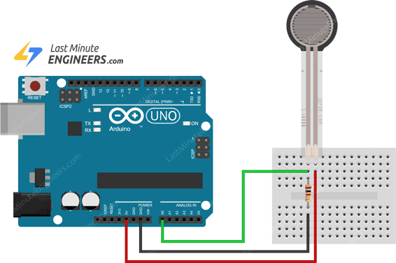
Figure 20. Force Circuit Schematic
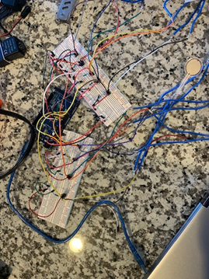
Figure 21. Force Circuits
The solenoids were then connected to the Arduino motherboard. Since the solenoids actuate the airflow to the pneumatic motors, hosing was used to connect the solenoids to the motors. The team’s plan is to use one compressor hose to provide air input to each solenoid one after the other. A schematic of the solenoid circuit is shown in the figure below.
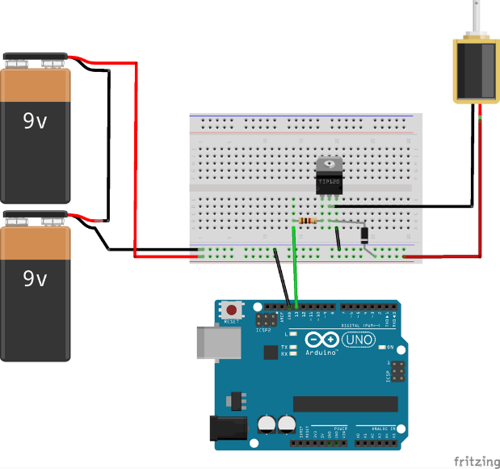
Figure 22. Solenoid Circuit Schematic

Programming
The team initially used Arduino to program the force sensors and solenoids. The team also used MATLAB to perform center of gravity calculations. These codes then had to be incorporated with each other to be able to move the counterweights for the device. The team had trouble getting the solenoids to work and eventually had to order different solenoids to complete the project. The team had to condense three scripts into one script for ease of operation. The figures below show examples of the force sensor code in Arduino, followed by the force sensor code using MATLAB. The codes are fairly similar despite a few language differences.
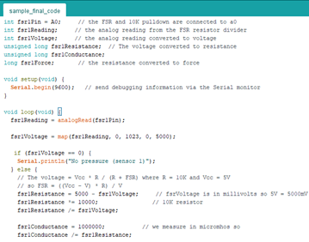
Figure 23. Arduino Force Sensor Code
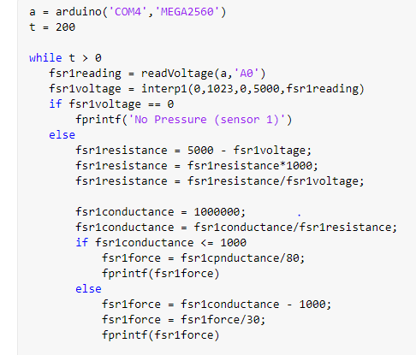
Figure 24. MATLAB Force Sensor Code
As you can see, the equations are the same in the Arduino and MATLAB codes. The team created the code for the solenoids by timing how long it took the counterweight to move from one side to the other. By implementing time, the program will provide air for a certain amount of time to the motors based on the desired distance. The pneumatic motors will only run for the amount of time coded into the solenoids. This is important because it makes sure the pneumatic motors do not move the counterweights to one side or the other. To align the center of gravity of the platform with the center of gravity of the CubeSat, the counterweights must be precise in the x-direction and y-direction. A piece of the final code is shown in the figure below. This code is part of the deliverables to our client along with the CAD package, operation of assembly manual, and final built prototype.

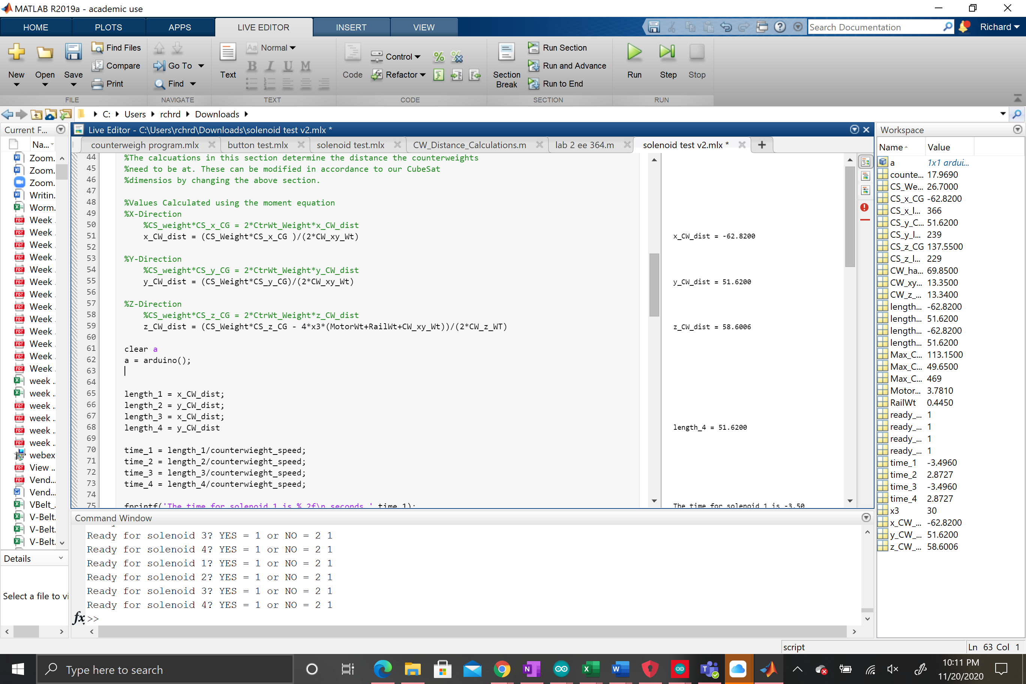
Figure 25. Portion of Final Code

IMPLEMENTATION – Second Semester
Throughout the design process and the manufacturing process the team had to make some design changes. These design changes helped improve the overall function of the device and made it smoother to build. The changes that were made were broken down by which change effects the subassemblies of the device.

Design Changes in Second Semester
The following sections go over the design changes made by the team since the critical design report at the end of the first semester. The changes were justified by calculations and ease of manufacturing. Design changes are essential to the engineering design process and occur often in industry, the following sections discuss the design changes made and the justification for each decision.

Design Iteration 1: Change in Securing Subsystem Discussion
The original design for the securing subsystem came from specs given to the team by General Atomics. The client’s already designed a clamping system to mate with the tabs on the CubeSat, which was ideal to use in our design since these clamps were a perfect mate. However, the team did not have the resources or time available to wait for manufacturing of this system. The drawing with dimensions of the original design is shown in the figure below.
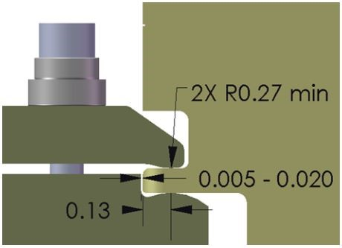
Figure 26. Original Clamping System Drawing
This design change was discussed in short in section 5, but the main reason was because the team did not have time to wait for the parts to be manufactured. Since General Atomics has already made this, the team determined they could add this to our prototype at their discretion. Our team decided to go with a sliding rail system for ease of manufacturing. The team manufactured the railing without having to outsource it to a machine shop, which was ideal in saving time. This railing system also works with the tabs located on each side of the CubeSat. The CubeSat slides into the railing until it hits the rear plate. Thereafter, the front plate is slid into place and the CubeSat is then secure. The team justified this design change since it was simpler than the previous subsystem design and still meets the customer need of securing the CubeSat during testing. The final securing subsystem design is found in section 5.3.

Design Iteration 2: Change in Z-Direction Counterweight System Discussion
The original design for the mounting fixture includes 8 screw-weight (rail) assemblies. There were four rail assemblies that adjust the CG in the x- and y- planes, that is moving the CG about the plane of the platform. The adjustment of the CG z-component used four additional rails assemblies oriented in the z-direction. Displacing the counterweight displaces the CG normal to the platform. The number of rails and their geometries were decided so that our device could be symmetrical about all three-coordinate axis. We anticipated the CG for the platform alone to be at the geometric center with absolute symmetry.
As the project advances, the team is addressing more details of the design as we are obtaining/requesting more documents from the customer.

We initially designed our rail assemblies to adjust the CG for objects with awkward center of gravities, designing for the worst case. Our analysis for the counterweight system resulted in power screw lengths equal to length of the CubeSat edge, and 45 lbs counterweights. This design failed to stay below our ER for total weight. To address this concern, we obtained sample payload specs for General Atomics’ 12U CubeSat. This information was not requested earlier as our device was supposed to accept other payloads and projectiles beyond just a CubeSat. Now our design is focused on testing only CubeSats, assuming the 12U is the largest. The team used the specs to adjust assumptions in the counterweight analysis. As a result, we only require 5 lbs for each counterweight, each power screw is 10 inches long, and we were able to remove two vertical rail assemblies from the design. Our CubeSat design now has 6 rails assemblies in total.

Figure 27. Final Counterweight Assembly

The team used concrete to mold the counterweights after the discovery of the maximum weight mentioned above. The z-direction counterweights were initially at equal lengths above and below the platform to displace the CG. However, the team determined through CG calculations that the majority of the length must be below the platform to align the CG of the CubeSat with the CG of the air bearing stand.
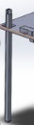
Figure 28. Z-Direction Final Assembly

Design Iteration 3: Change in Pneumatic System Discussion
The Pneumatics system within the device is what will power the counter-weight system. Therefore, making it very vital to the entire fixture. Originally, the system was going to be very different than what it is today. However, the overall flow of how the Pneumatic Subsystem is set up has not changed that much. The order in which the Pneumatic System is set up can be seen in the figure below. Where the parts of the device are the following: an air compressor, air tank, solenoid, pneumatic motor, connectors/valves, and hosing.
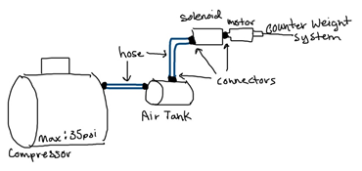
Figure 29. Pneumatic System Sketch
The first iteration of the design of this subsystem was to have almost every part internalized within the fixture. This meaning that the compressed air tank, would be internal, and it would be hooked up to the solenoids and then those would be attached to each motor. However, with the tank being inside of the fixture would make the size of the entire design be larger, and the tank would have to be minimized. The team wanted the device to be able to run multiple times, and with the tank being small then this could not occur. Therefore, the team decided it would be best to leave the tank outside of the fixture and have it attached through a hose.
The second iteration, then had the tank separate attaching to a valve within the device, which would then connect to a solenoid that would separate the air to the six different motors. As the team was setting up the Bill of Materials and finding products that they could buy for the device, it found difficult to purchase one solenoid that would be able to split to six different air flows. Also, having the compressed air separated into six different air flows would minimize the pressure going into each Pneumatic Motor, making those motors less efficient. There would also be a complication in setting up six different hosing mechanisms inside of the system. Instead, the team has landed on to the current iteration.
The current design has six different ports for the air tank to be connected to. These six ports start with a separate solenoid, that will communicate with the Arduino to know how long it must stay open. Then the solenoid is directly connected to the Pneumatic Motor, which is connected to the counter-weight assembly. The hosing from the Air Tank must be connected to each of the solenoids individually in a specific order. The team is setting up the code to pause after each solenoid opening time, so that the user of the device can disconnect and re-connect the air tank to the next position. This iteration was agreed upon since it will be the most efficient. The location of the solenoids on the fixture can be seen below.
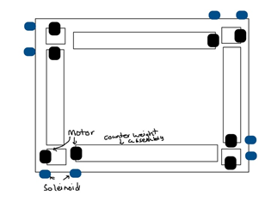
Figure 30. Motor/Solenoid Placement Sketch
The solenoids being on the outside of the device will allow for easy connections for the user to the air tank. This placement will also limit the amount of hosing used within the entire device, therefore limiting the amount of head loss within the air flow. Each of the solenoids will be connected to the Arduino that is going to be located in the center of the fixture.
For this current iteration, the team has purchased all the associated parts to build it and are waiting for them to be shipped. A small pneumatic assembly was created to test the motors worked, and from there the actual assembly attached to the fixture, will be made.

Design Iteration 4: Change in Electrical System Discussion
In the initial design, the electrical system consisted of the force sensors sending readings to the Arduino board, which in turn sends tells the solenoids to send air through the pneumatic motors for a certain amount of time, which is dependent on how far the counterweight needs to travel along the leadscrew.
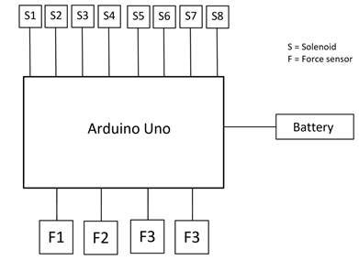
Figure 31. Original Electrical Subsystem
Since the team acquired some components for the prototype, some additions were suggested by team members. It was suggested that the team utilize a smaller battery for the device, because the one that the team has on hand is too large to fit inside the spherical cavity underneath the fixture. Another change that was made was the Arduino board that is being used for the fixture. The team also decided to incorporate accelerometers into the design for two reasons: to better detect if the device is at an upright angle, and to verify if the CG calculations are correct. It was decided that and Arduino Mega would better suit our needs over the Arduino Uno because there are more input and output ports that accommodate all of the onboard sensors. Additionally, as stated before, the team downsized the number of pneumatic motors being used in the system from eight to six, which led to the team changing the number of solenoids accordingly.
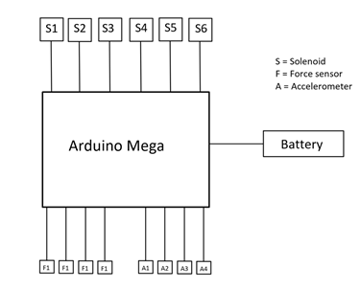
Figure 32. Current electrical subsystem

RISK ANALYSIS AND MITIGATION
To ensure that the device that would be constructed would not lead to any major failures or cause any injury, the team performed a couple different failure analyses, mainly during the first semester in the project. After taking into consideration about the possibilities on what could go wrong with the design, the team found some ways to either reduce the likelihood of a risk occurring or nearly eliminating it all together.

Potential Failures Identified First Semester
Last semester, the team performed a Failure Modes and Effects Analysis (FMEA) last semester in the form of some basic templates that were given by the client. The first step for the team was to identify what could potentially fail on the design, and after that the likelihood and negative consequence level were both empirically ranked and evaluated. The results of this analysis can be seen in Figures # and # in Appendix B.

Potential Failures Identified This Semester
After constructing and running tests on the fixture, the team found no new potential failures that could occur on the device. If anything, the team found that some of the initial risks that could occur are actually marginally smaller in consequence and likelihood than once thought, though not enough to make any changes to the Summary Risk Report and the Risk Assessment Summary. This was determined while running tests on the fixture, when the team saw that almost not of the risks occur. The risk that did change somewhat the most was Risk 2, and this was because the team change the pneumatic fittings from push connectors to barb connecters and quick connect fittings which both happen to be more secure, leading to them being less likely to loosen or wear.

Risk Mitigation
The most likely risks that could occur would be Risks 9, 4, 5, and 8, and the team has found that these all stem mostly from whomever is operating the fixture forgetting a small step when making connections within the system. The easiest way to mitigate those would be to very clearly and boldly state in the Operation and Assembly Manual that the secure connections of those parts are crucial to the successful functionality of the device. While a few of the lowest ranked risks also could be mitigated by instructing a careful attention to detail, the other ones, particularly Risks 2, 3, and 6, had to be impeded in a different way. The team figured that since these risks are more likely to occur over longer periods of time, it was concluded that a regular maintenance check of the fixture, with an emphasis on those components, would be necessary. The exact regularity of these maintenance checks have not been determined, but the team as a whole decided that they should occur at least once every four weeks.

ER Proofs
The team ran multiple tests on the device that would verify that each of the ERs were satisfied. These tests were either physically completed or were a computational approach based on what aspect it was. The device that the team machined is a prototype of the final device and therefore not all ERs were able to be tested through physical approaches. The following sections are each of the verification that the ER is satisfied.

ER Proof #1 – Accept CubeSat (Lift Weight)
The team had a difficult time with trying to figure out how to prove that this requirement had been met under the guidelines that were set out by the client, and the ones that were set out by the team. Initially, it was thought that running an analysis of any potential structural materials would be enough to determine if the goal had been met, but in the process, one of the team members pointed there was an easier way to perform this evaluation. All the team had to do was use the material with the relatively smallest material strength and select the maximum weight of the CubeSat. Through some back of the envelope calculations, the team found that the fixture would indeed be able to support the CubeSat payload. Also, by happenstance, the material used to guide these calculations was the same material that the team ultimately used in the final product.

ER Proof #2 –Movability of CG in all Axis
This ER is based on where the CG is located once the CubeSat is attached to the fixture and the counterweights are moved to the correct location. The CubeSat has different CG locations internally, therefore the fixture that was designed must relocate that center of gravity to the center of the fixture.
To verify that the CG was relocated for the entire assembly multiple balancing tests were implemented. The first balancing test was to verify that the CG was moved within the x and y axis. A pin was placed under the fixture at the exact location that the CG should be, and if it balanced after the counterweights moved then the CG is relocated. This was completed for different payloads of the CubeSat being on the fixture and then moving the counterweights. It was also tested on wider and smaller pin diameters. The image below shows the fixture balancing on the pin with the CubeSat attached.
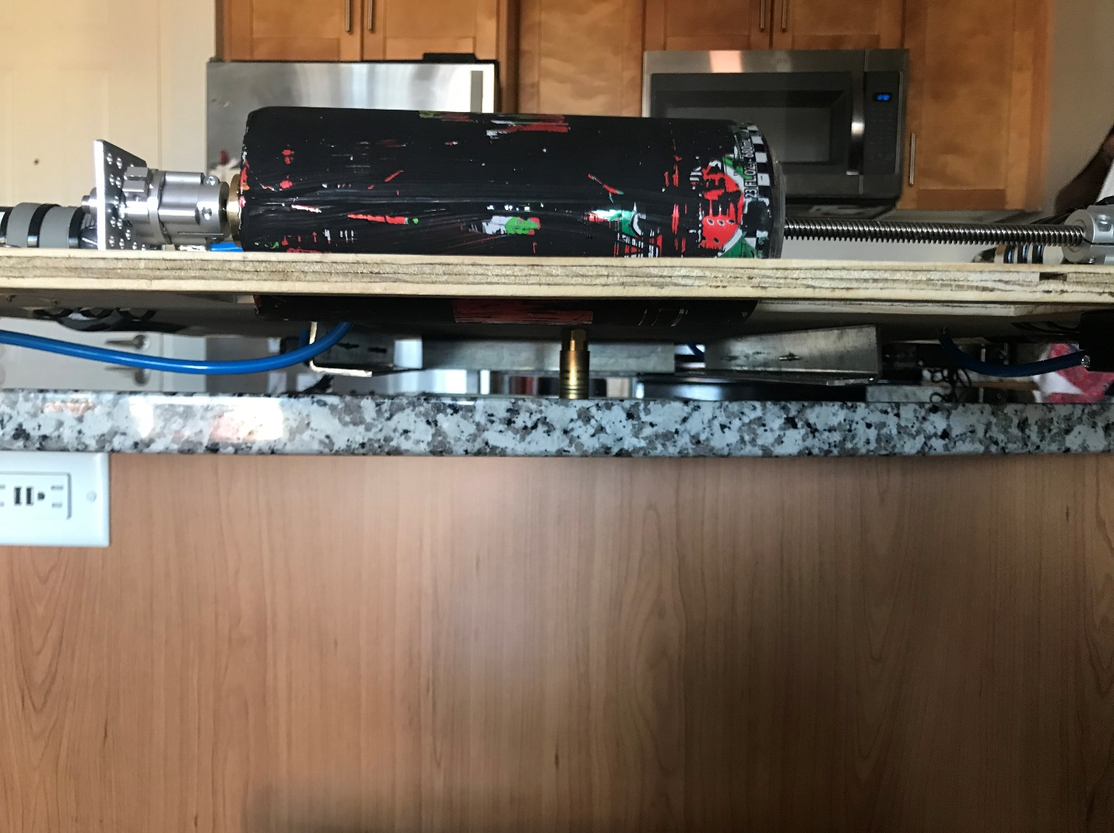
Figure 33. Balancing for the x and y axis

A similar test was completed to verify that the CG in the z direction was also relocated to the correct location. For this the counterweights were positioned on the z-axis rails to balance the weight of the CubeSat. Then the fixture was placed on its edge to balance on it. The image below shows this balance test.
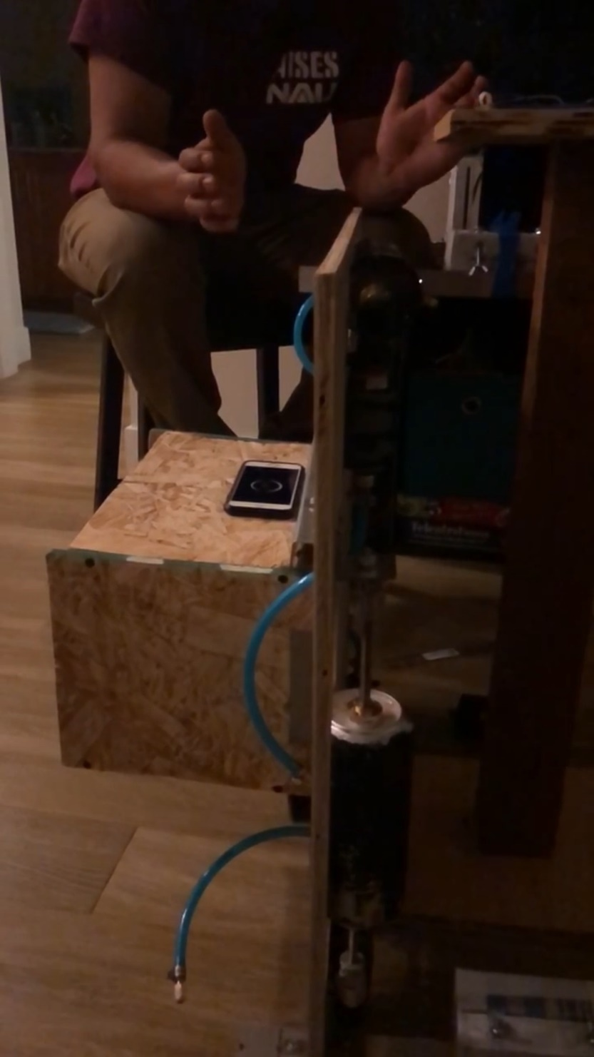
Figure 34. Balance test for the z axis CG relocation

With the combination of both of these tests, this ER is satisfied within the target and tolerance.

ER Proof #3 – Limit Tilt Degree
A code was written in the Arduino IDE to measure the angle of tilt that the CubeSat fixture was at in any given time interval. The initial code consisted of a single Arduino board which had an integrated accelerometer and an RGB LED. It was a relatively simple code that continuously measured the change in angle relative to the z-axis, and whenever that angle exceeded 30 degrees, then the LED would change from green to red. The next evolution of this code consisted of four accelerometers feeding signals to a single Arduino Uno and a different RGB LED. In this iteration, four accelerometers were used to help eliminate stray signals from any single sensor and to reduce scatter in the data.

ER Proof #4 – Allow for 360 Degree Rotation
This ER is based on the entire assembly of the device attached to the air bearing stand. Since the air bearing stand is able to rotate freely in any direction, then this ER is satisfied. No testing was able to be completed on this, due to the team not having access to the client’s air bearing stand. However, it is satisfied because the air bearing stand has this rotation ability around the z-axis on its own. So, when the device is attached to the air bearing stand it will have the same ability.

ER Proof #5 – Limit Total Weight
This ER is satisfied based on the material selection of the finalized design, and the weight of each of the objects. With the selection of each of the materials and counterweights the entire system will be under the maximum weight allotted for this device. In total the final design should be approximately 30 kg which is way below the maximum target of 50 kg.

ER Proof #6 – Limit Size
This ER is satisfied just based on the dimensions of the finalized design. As the team went through the design process, they assured that the fixture would not increase size past this requirement. In total the size of the fixture is .379 cubic meters. But the fixture does not take up the entire volume of that size. The fixture is a semi flat square measuring 77 cm on both sides. Then, the z rails which only come off of the fixture in two corners are 64 cm long. Therefore, the device is easy to transport and store once the z rails are removed.

ER Proof #7 – Lifetime Cycle
The team was mainly concerned about the lifetime cycle of the lead screws, because it was decided by the team that since those components would be moving the most and it’s the one part that would be put under the most load and stress. To find the life cycle of the screws, the team simply used one of the spreadsheets used to analyze rotating beams from previous courses. The team simply modelled the screw as a solid shaft with a moment being induced in the middle of the shaft. The resulting calculations showed that the number of cycles that the screw could undergo before failing was under the engineering requirement set forth by the capstone team.

LOOKING FORWARD
As the project is ending, the team decided to reflect on what has been accomplished, but also what could still be worked upon if there was enough time allotted for it. This section provides the information on different tests that the clients should undergo when receiving the device. It also contains future work that the team would implement if more time was allotted to the project. It just describes what things should still be completed on the project.

Future Testing Procedures
Once the client has built the finalized the device one last test must be ran with the fixture being attached to the entire assembly. This test was not able to be ran because the team did not have access to an air bearing stand or to a 12U CubeSat. The team created models of both of these devices and tested the fixture using those models, but the overall test has to be ran. The outline of this testing procedure and how it should be ran is below.

Testing Procedure: Final Test on Entire Assembly
The final test that needs to be ran on the device is to test the functionality of the fixture with both an actual 12U CubeSat and an air bearing stand. This test checks that all of the other tests and equations that were evaluated are correct, and that everything runs smoothly once being actually used.

Testing Procedure: Objective
To begin the test the entire finalized design must be set up and built according to the assembly manual. Once, that is complete and everything is tightly secure to the fixture, then the walk through could be completed. The exact way to set up the fixture before it is being used and tested is also described in the user manual. The fixture should be placed on top of the force sensors and then the CubeSat should be attached to the fixture. Once the code is run through and all of the counterweights are at the correct location then the fixture can be attached to the air bearing stand. Once the fixture with the CubeSat placed on top is attached to the air bearing stand than the test can commence.
The first step of the test is to visually verify that the assembly on top of the air bearing stand is balanced. If there is a tilting affect then the device should immediately be taken off and the counterweight location code should be ran again. If no tilting occurs, then the next action can be taken.
The next step of this test is to run a simple test on the CubeSat while implementing the tilt code. Once the fixture tilts past a certain degree a sensor on the fixture will go off. This assures that the programming associated with the final device is accurate.
Overall, this test is primarily a finalized version of the testing process to assure that it works on the air bearing stand. It is a visual test allowing for the fixture to be attached to devices that were not accessible to the team.

Testing Procedure: Resources Required
The necessary resources that are required to run this test is a CubeSat, an air bearing stand, the device, and a computer to run the program. There is no other necessary tools or resources required other than that. The person running the test should though have access to the Assembly and User Manual to assure that the device is put together properly and that it is being utilized correctly.

Testing Procedure: Schedule
The first part of this test should only take a couple minutes, as it is being visually ran. Then, the next step of the test will take as long as the clients test on the CubeSat would take. Overall, it is a just a brief test to verify connections are correct.

Future Work
The project moving forward into the future still has some work that needs to be completed on it. Firstly, the actual device made out of the materials that were chosen by the team. This includes getting the counterweights manufactured by a company out of lead, and the platform manufactured out of aluminum. Then, the actual device would have to be put together and similar tests ran on it that was performed on the prototype. Further work to optimize the device would be developing a faster and shorter program to run through the entire system.
If there are errors that arise from the test to attach it to the air bearing stand further design changes and tests may need to be implemented. One suggestion would be to use different fasteners to screw on to the air bearing stand. Or a different system of attaching it to stand.
If a future team working on this project would like to limit the weight of the device, then the size could be increased. The longer the rail system for the counterweights are then the less the weights need to be. Another suggestion would be to drop the rail system of the x and y axes in order to decrease the amount of weight needed for the z-axis.
One other piece of advice for a team continuing this project would be to order correct parts from the same vendor so that each part would fit together correctly. Also, assure that each part is correctly working, and to order extra in case there is one sensor or one solenoid not working correctly.

CONCLUSIONS
The purpose of this project was to create a testing fixture for a 12U CubeSat that would relocate the CG of the entire assembly in order to be attached and tested on an air bearing stand. The team had also created some personal goals that they wanted to accomplish throughout the project. One of the team’s goal was to have a high quality and successfully working product at the end of the year. They also wanted to assure that all parties, the clients, fellow team members, and the professor was being updated at each step of the processes. The last goals were that the team members wanted to have a successful capstone course, learn more about the design process, and be successful within the course. The team was able to have success in reaching all of the goals mentioned. The team created a working prototype of the design and have had a successful time throughout the capstone courses. The team also assured that each party was being updated regularly with what was happening with the project.
At the end of the project the team reflected on what has been accomplished. They also reflected on what was a success and areas of improvement for the overall project. Each of these components are described below.

Reflection
The device that the team designed and built was very specific to what the clients wanted for the project. The team made sure to work closely with the clients to create something that would work for their necessary tests on the CubeSat. However, the team also thought about how the device would be safe to any user, and what effects the project may have on the environment.
The team made sure that the device was safe by creating ER that satisfied safety regulations within a workplace. The team also created a user manual describing the proper way to set up, take down, and use this device. The ER that were created make checks on how safe the project is in terms of its ability to fall of the test stand, and center itself. Overall, with the ER that were tested the device if used appropriately is safe.
The team also thought about who could benefit from this project once it was complete. The main focus is displaying the information that was learned to outside resources, so that globally other companies could use this information and better the device for their needs. The team also made sure that every part that was chosen to be on the device could be readily available, so that other people could recreate the device. Overall, what the team learned throughout this project can be shared with people around the world.

Post Mortem Analysis of Capstone
After completing any major project, a reflection should be made by how the overall project ran, and what different aspects contributed to the project’s success or failure. That is what this post mortem section is about. It is the ability for the team to reflect on everything that was accomplished during the year and to think about how the project and process went overall, what areas contributed to success, and what areas could be improved.
Overall, the team completed the project mission of designing and creating a 3D prototype for the client. During the first semester of the project the team created multiple design variants and then choose one single one to develop more, and to continue to design. This design variant was also approved by the client. Then, during the second semester the team built and manufactured a working prototype to test some of the requirements that were established by both the client and the team.
From the beginning the team and clients established that the end product of this project would be a 3D prototype of the design, and a fully described CAD model of the proposed design. The team also said that through this project they would utilize the knowledge that was taught in previous engineering courses and build upon that to design and build a fully working prototype. All of these things were accomplished throughout the year, and the team gained more knowledge through the process of this project. Therefore, the overall mission of this project was a success.
With the main mission of the project being a success there were multiple different things that contributed to that success. However, there were also some areas throughout the project that negatively affected the process and could be improved. The following two sections describe what aspects can be contributed to the success of the project, and what areas could have been improved.

Contributors to Project Success
During the year, the team had many different contributions that led to the overall project being successful. The main attribution that led to the project’s success was the communication between the team. Throughout the year the team made sure to consistently update the other team members on what was going on. The team also made sure to meet at least once a week through Microsoft Teams to show the updates and to describe what each person has accomplished. The team had also made sure that since the team was separated, that the team would split up the tasks that each person would accomplish to help get all of the work done in a timely manner.
Another item that contributed to the success of the project was the team’s ability to think on the fly and be adaptable. The team had come across a lot of issues with the parts that they ordered not fitting together correctly, even though they were the same dimensions. So, the team had to continuously made changes to the device and order more parts to be able to set up a fixture that would work. The team was always very adaptable to the situation that the project was in and was always thinking about next steps that could be taken.
The last attribution that was a success to the project that was provided through the team’s skills was the team members ability to continuously learn. The team had to learn about different aspects that the project had. For example, the team had never built something utilizing a pneumatic system prior to this project, and so they had to learn how to successfully set one up and to understand what needs to be actuated to make it work. The team had to also learn how to code different programs through an Arduino system and combine that with a Matlab code. Utilizing an Arduino in the capacity that was used for this project was new to most of the team members, and therefore had to learn about those aspects. The team also had to practice more of their skills with utilizing SolidWorks a 3D CAD Model. As well as the engineering concept of locating and relocating the center of gravity, and technical writing or communicating. The last thing that the team learned throughout this project was about the manufacturing and building process. The team had very little experience in actually designing and building an entire device from start to finish. So, throughout the process the team had to make adjustments, and learned how much work goes into the building stages. All of these different aspects were what the team members devoted their time to continue to learn and improve their knowledge within these areas.
Other items that contributed to the team’s success was the quality of paperwork that the team turned in, the given budget of the project, and that the overall purpose of the project was to build a prototype. The team throughout the year had high quality reports, memos and presentations that were well written and put together nicely. The team was able to explain the process that was being completed and describe the updates that have been made on the project. This allowed for a successful grade within the class, which was a goal set by the entire team. The provided budget allowed for a lot of flexibility in the decisions that were made for specific parts of the device. It also allowed the team to purchase new products when the old ones were not working correctly. Finally, from the beginning the team knew that the finalized product would just be a prototype of the design. This allowed for the team to spend more time on building, then wasting time on waiting for specific machined parts to come in. This allowed the team to complete the prototype and know what parts should be outsourced to be machined for the finalized device.

Areas for improvement
The team had also run into some problems during the process of designing and building the device. These problems that the team encountered can also be described as areas for improvement that the team would do differently, if they were able to complete the project again.
The first main problem that the team encountered during this project was that parts were not fitting together properly. The parts that the team purchased were nominally the same size, but then when they got delivered, they still did not fit together. The team believes this is because every company has different specifications that they have for their parts and how they dimension their parts, and so ordering from multiple different vendors created this issue. If this project could be redone the team would make sure to order each of the parts from the same vendor. Or, if the team was creating this device under an engineering company, the company would have a in-store shop where the team could collect all the correct parts from.
Another, problem that the team encountered was because of the pandemic that is currently happening. Due to this it was difficult to get specific parts that the team wanted because the shipping time was too long. If the part would take too long to come in, then the team decided to get a different part from a completely different vendor. This also ran into different parts not working properly because they came from less known vendors. The timeline of the pandemic also disallowed the team to have the main part of the fixture be outsourced and manufactured. So, the team had to create specific parts of the project on their own which made them lesser quality. Also, because of the pandemic occurring, it made it more difficult for the entire team to meet in person. This caused timelines to be pushed back because of the members working on separate parts, and then not being able to put the full project together.
One major issue that the team encountered was not planning the timeline of the project properly. As mentioned, this is the first project where the team has had to create an entire device from start to finish and have a built product. Therefore, the team did not plan for the building to take as long because they thought that less problems would occur. This meant that the team fell behind within the timeline because the building process was taking longer than expecting. This also made the different assignments that the team had to turn in be completed within a short amount of time, as well. Now, that the team has experience in building they know now to allot for more time within this process. The team would also make sure to create a better and set timeline and stick to it harshly with set up deadlines.
The last area for improvement for this semester is the communication between the team and the clients. The first semester that the team was working on the project, the team met with the clients almost weekly. Therefore, the team was able to get a lot of assistance in making decisions and answering any of the questions the client may has. This semester the communication with the client dropped because of the sponsors and the team getting busy, as well as the pandemic not allowing for in person meetings. This is one thing the team would approve on, so that they could get more aid in the decisions that were made during the building phases.

References

[1] | Planetary Systems Corporation , "Canisterized Satellite Dispensar," 3 Aug 2018. [Online]. Available: https://www.planetarysystemscorp.com/product/canisterized-satellite-dispenser/. [Accessed March 2020].
[2] | Macintyre Electronic Design Associates, Inc., "HCS-01 Three-Axis Helmholtz Coil," MEDA, Inc, Herndon, 1998.

APPENDICES

Appendix A: CubeSat Testing Fixture House of Quality

Appendix B: Failure Modes and Effects Analysis
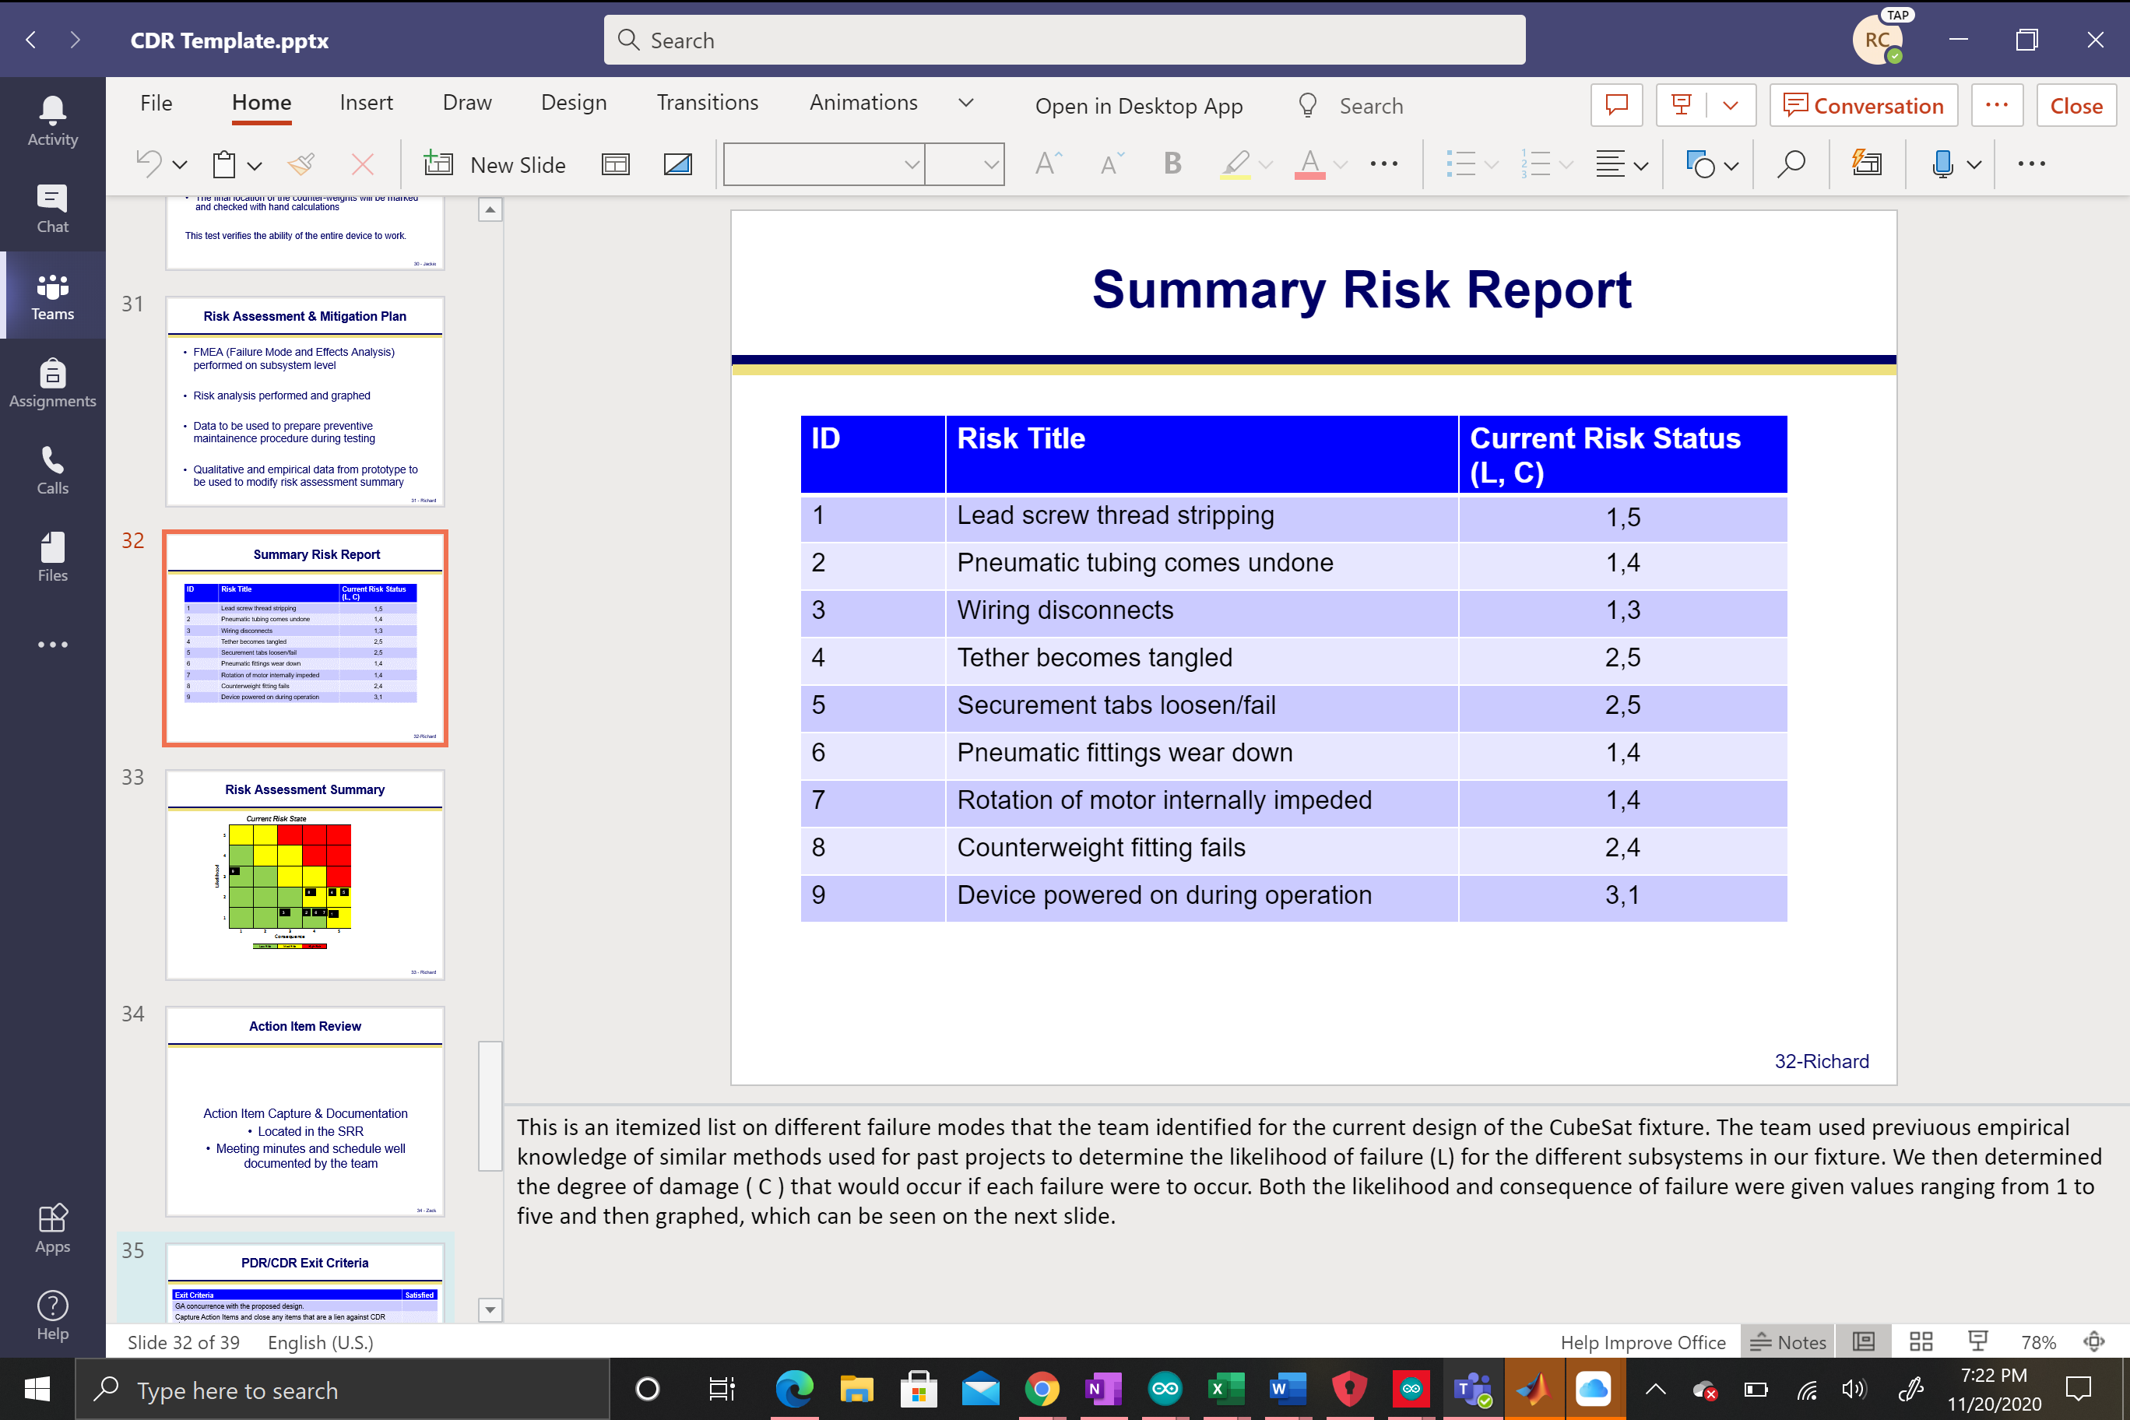
Figure 35. Summary Risk Report
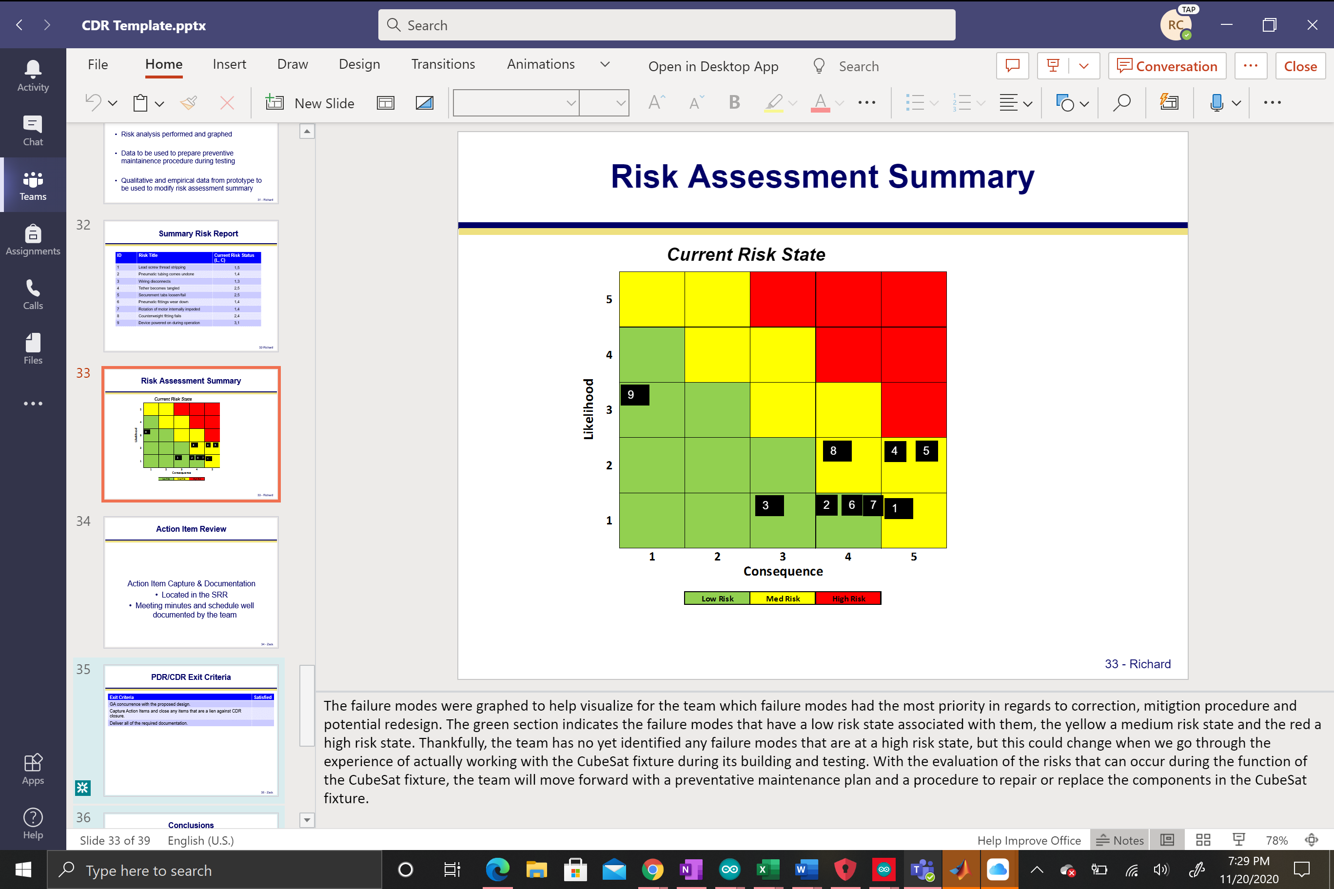
Figure 36. Risk Assessment Summary

